CHAPTER 11
TABLE OF CONTENTS

I. CHAPTER 11 – CASH CONTROL 1
II. OVERVIEW 1
III. TRAINING 1
IV. INTERNAL CONTROL 2
A. Documentation 2
B. Cash Handling and Security 2
C. Separation of Duties 3
D. Processing Cash Received 3
E. Checks 5
2. Co-Payable Checks 6
3. Third Party Checks Not Accepted 7
4. Returned Checks 7
F. Keep Personal Data Secure 7
G. Balancing 8
H. Daily Deposits 9
I. Routine Reconciliation 10
J. Refunds 10
K. Voided Transactions 10
L. Change in Custody of Cash/Cash in Transit 11
V. CASH RECEIPT FORM 11
A. When to Use the Cash Receipt Form 11
B. PeopleSoft Finance System/Cognos Reporting System Effect 11
VI. CASH DISBURSEMENTS 13
A. PeopleSoft Finance System Effect 13
B. Overages/Shortages 13
VII. CHANGE FUND 14
A. Proper Use of Change Funds 14
B. Establishing a Change Fund 14
C. Using and Maintaining a Change Fund 16
D. Closing a Change Fund 17
VIII. PETTY CASH FUND 17
A. Proper Use of Petty Cash Funds 18
2. Study Subject Payments made with Petty Cash 19
B. Establishing a Petty Cash Fund 20
C. Controlling the Petty Cash Fund 22
D. Using and Replenishing the Petty Cash Fund 23
3. Confidential Study Subject Payments 24
E. Modifying a Petty Cash Fund 25
F. Changing the Custodian 25
G. Increasing the Authorized Amount 25
H. Decreasing the Authorized Amount 25
I. Closing a Petty Cash Fund 25
J. Revocation of a Petty Cash Fund 26
K. Petty Cash/Change Fund Request Form 27

CHAPTER 11 – CASH CONTROL
The purpose of this chapter of The Accounting Handbook is to provide information about cash control. Departments are responsible for complying with cash control policies and procedures as outlined in this chapter and also for developing detailed written departmental operating procedures. Departments are also responsible for training designated employees in cash handling policies and procedures to address the processes and practices within the department.

OVERVIEW
For purposes of this chapter, cash consists of:
- Paper currency
- Coin
- Checks, credit card checks, traveler’s checks
- Money orders
- Credit/Debit card receipts
- Wire transfers
- Charge card slips
- Gift cards or gift certificates

Typically, departments receive cash in the course of their sales activities. Cash can also be received as a result of a vendor refund due to returned goods or services. Cash may be received at the point of service, via US mail, electronically, lock box, the Automatic Clearing House (ACH), internet, or payment drop boxes.

Cash operations should be limited to those departments that have the ability to physically secure the cash, implement safeguarding practices, and enforce control procedures. Potential risks relative to the cash on-site, and also to the individuals handling the cash, must be continually monitored. Identified risks must receive timely mitigation.

TRAINING
In addition to this chapter, online Cash Control training is available
via SkillPort in the portal.

INTERNAL CONTROL
The following is a list of internal control techniques departments must employ when handling cash. Continuously assess internal controls over cash and take appropriate action to remediate any concerns noted.

Documentation
Document policies and procedures that address the department’s cash handling practices.
- Identify the purpose for which cash is maintained or received.
- Identify cash locations (i.e., know where cash is at all times).
- Designate the positions that are responsible for receiving & handling cash.
- Ensure all Cash Receipt functions are properly authorized.
- Document the steps and associated internal controls that occur from the beginning of the cash handling process to its conclusion, for each type of cash location.
- Train all individuals assigned responsibility for cash.

Cash Handling and Security
Cash must be secure at all times.
Each individual who receives (or has custody of) cash is responsible and accountable for the cash under his or her control, and individual accountability must be maintained and documented for all cash handling procedures.
- Minimize cash at each location to the amount necessary for business.
- Designate each cash location (e.g., cash register drawer, safe, locked box, bag, drawer, or cabinet) as being the responsibility of a single person, and that person should be the only one able to access the designated cash.
- Restrict authority to get into cash registers and locked boxes, bags, drawers, or cabinets.
- When using a safe to secure cash, limit the number of people who know the combination to the safe.
- Ensure the combination to the safe is changed periodically and whenever there is turnover in key staff.
- Limit the number of keys to locked boxes, drawers, cabinets, bank bags, or other containers used to secure cash.
- Implement appropriate security over the cash (e.g., locks, alarms, cameras, armored car) at all times including when cash is being transported.

Cash responsibility should be assigned to a single individual whenever possible. Each designated cash location (cash register drawer, safe, locked box, etc.) and amount should be the responsibility of a single person: the cash custodian. The cash custodian should be the only person who has access to that designated cash. If access to cash cannot be restricted to a single individual, then the department should deploy appropriate mitigating controls, such as:
- Log transactions by individuals
- Use a camera to record access
- Reconcile the cash between individuals having access to the cash.

Separation of Duties
There must be a separation of duties between staff responsible for receiving and depositing the cash and the staff responsible for the accounting records.
Maintain separation of duties throughout the cash handling process. Staff authorized to physically handle cash should not:
- Reconcile monthly financial statements to verify that all cash was properly deposited.
- Have access to accounts receivable records.
- Be involved in the accounts receivable billing process.
- Be involved in the disbursement function (authorizing expenditures).

Where separation of duties is not possible due to the small size and limited staffing of a department, implement compensating controls appropriate for the nature and size of the operations. Ensure that key personnel take leave, as granted by university policy, at a minimum of at least once per year.

Processing Cash Received
Process and record cash as soon as it is received.
Cash typically is received by the University in one of three ways: from in-person cash sales, through the mail, or via electronic means. No matter how cash is received, the requirements below apply:

- Accept only U.S. currency when collecting cash. If your department has a revenue contract with a foreign entity, then it may accept the following risk for accepting foreign currency or foreign checks (regardless of currency). The department will be at risk of loss for the foreign item until the item is fully collected, and any such items received will be handled as collection items per the University bank’s foreign item collection policy.

- Accept only payments for official university business. If your department is involved in a non-university activity that generates funds, such as soliciting contributions for a retirement function, instruct people not to make the checks payable to the University of Colorado. The university cannot endorse these over to an individual or an organization, or deposit them into a SpeedType-Account combination and withdraw the funds. If this situation occurs, return the check to its maker with an explanation and a request to re-issue the check with a corrected payee.

- Maintain separation of duties whenever cash is collected. A single person must not have complete control over collecting cash, issuing Cash Receipts, and depositing cash. Any individual involved in the cash handling processes should not perform tasks such as collecting accounts receivable and maintaining the accounts receivable records or performing the financial report review process.

- Use a Cash Receipt log. Whether cash is received in person or by mail, there must be a system to record all cash as soon as it is received. Examples of such systems include writing out manual sales slips, preparing a log of receipts as the mail is opened, or using a cash register. A cash receipt log can be used in either of the following ways:
    - If two or more individuals are involved, one individual collects the cash and places it in a secure container, and the other individual records the amount and type of payment received along with the payee’s name and date.
    - If only one individual is involved in collecting the cash, then a receipt from a receipt book containing pre-numbered, duplicate receipts must be completed by the individual. The receipt should note the payee name and date, amount, and type of payment. One copy of the receipt should be given to the customer and another copy of the receipt should be maintained in the receipt book. If only one individual is involved in receipting cash due to the small size and limited staffing of a department, then compensating controls appropriate for the nature and size of the operations must be implemented.

- Document cash sales with duplicate, pre-numbered sales receipts or through the use of a cash register. Whether the process used is manual or automated, the documentation for cash received from sales must include the name of the department, the date the cash was received, and the form of payment (e.g., cash, check, credit card). If possible, the documentation should also include a description of the items sold, the quantity sold, the unit price, and the extended price.
When cash collection involves a cash register, assign each cashier a unique identifier. This identifier must not be shared with or accessible to other individuals. Provide each cashier with a cash drawer to which only that cashier has access. Instruct cashiers to lock all cash in the drawer or in a secure receptacle whenever they leave the immediate cash collection area. Maintain the numerical sequence of sales receipts from one sale to the next. Provide each customer with a copy of the cash register receipt.

Checks
Endorse checks immediately upon receipt. The endorsement should consist of a stamp on the back of the check that records the following information:

FOR DEPOSIT ONLY
The Regents of the University of Colorado A Corporation
Wells Fargo #182-3472752
Dept Name:_________________________________________
SpeedType #_________________________________________
Account #___________________________________________

- The Dept Name should be the department submitting the Cash Receipt.

- The SpeedType- account combination should be the SpeedType you want to use to record an account receivable in case the check is rejected by the bank.

Generally, an Auxiliary SpeedType should be used for the check endorsement unless it is a gift directly to the university. Gift checks should be deposited to the Treasurer’s Gift Clearing speedtype 13468785, account code 070504 (Gift Clearing Suspense) and include the destination gift SpeedType in the Remarks section—see Chapter 15, Gift Accounting. When a check is returned due to non-sufficient funds, the accounts receivable is recorded using a balance sheet account, and the transaction is reflected on the monthly m-Fin Balance Sheet Summary. A review of the transaction on the m-Fin Financial Detail report will indicate whether any non sufficient funds check accounts receivable have been recorded.

- Endorse checks received through the mail immediately upon receipt. Mail should be opened immediately, checks identified and deposited. Prepare a log or copy the checks. Deposit the checks and send the log or check copies to the staff that will use them to verify the SpeedType-Account records and post the customer records. The staff responsible for the accounting and billing processes should never handle checks.

- Do not retain (shred) copies of checks once the monthly reconciliation process has shown that the checks have been appropriately deposited.

Co-Payable Checks
A co-payable check is one that is made out to more than one payee. At the university, this can occur when a scholarship check is made out to the student and to the University of Colorado.

If a check is jointly payable to the university and a student, the university may negotiate the check without the student’s endorsement only if:
- The funds are applied solely to the student’s benefit.
- There is no wording on the face of the check that would require the student’s endorsement such as “Borrower’s Signature Required” or “Endorsement Constitutes Acknowledgement of Changed Agreement.” These restrictions are often found on certain student loan program payments received by the university.

If the check meets the above two requirements, the back of the check should be stamped with both the university’s endorsement and an Absence of Endorsement Guaranteed stamp below that. The full amount must be deposited to the student’s account. That is, there can be no cash back nor can the funds be deposited to multiple student accounts. The university will not accept a check if the university is not named as one of the payees, or if there is more than one student named as co-payee.

Third Party Checks Not Accepted
A third party check is a double-endorsed check whereby the payee endorses the check by signing the back, then passes the check to a subsequent holder, who endorses it prior to cashing it. For example, a third party check to the university is created when the original non-university payee writes “Pay to the order of the University of Colorado” and then signs below. The university does not accept third party checks. A third party check differs from a co-payable check described in the previous section in which the university is named as one of the payees.

Returned Checks
Occasionally, checks accepted for payment will be returned by the bank due to insufficient funds or a closed account. When this occurs, the department will be asked that the check(s) be picked up in person. Returned checks force an involuntary credit-granting situation on the department. Therefore, sufficient information should be obtained for each check accepted to facilitate the collection process if that becomes necessary. At a minimum this information would include:
- Name
- Address
- Phone number
- Other identifying information such as student number or Colorado driver’s license number.

Keep Personal Data Secure
Restrict the collection of personally identifiable information and protect unauthorized use of credit card accounts.
Do not record credit card or Social Security Numbers on checks.
Colorado law prohibits recording certain information when accepting a negotiable instrument as payment, such as a check. A person accepting payment by check shall not record or require the maker of the check to record a credit card or Social Security Number given as identification or proof of creditworthiness.

There are three exceptions to this rule:
  - A credit card number may be written on a check only when paying the credit card account represented by that number.
  - The recording of a person’s social security number on a check or other negotiable instrument issued to pay a student loan.
  - The recording of a person’s social security number on a bona fide loan application.

A cashier may request a purchaser of goods or services to display a credit card as indication of creditworthiness or identification. It is permissible to record the type of credit card and the issuer of the credit card on a check.

Credit Card Receipt Processing
Per State Law C.R.S. 6-1-711 departments that accept credit, charge, or debit card payments and print receipts electronically must:
- Print no more than the last four digits of a customer’s card number or print the card expiration date on the customer’s card receipt.
- Transmit the credit/debit card information to the University’s financial institution using the approved system. (Consult Treasurer’s procedures.)
- Obtain the authorization # and record it in the cash register or receipt log.
- Not retain the full credit card information outside of the approved Treasury credit card procedures. See the Acceptance of Payment Card Cost and Risk APS for additional security standards.

Balancing
Cash receipts must be balanced daily to the sales records.
Before cash can be deposited, cash receipts must be balanced daily to the sales records. This includes daily balancing of cash drawer receipts with sales records or cash register tapes, and balancing cash received through the mail with the mail log. A totaling of a cash register tape is referred to as a “Z” reading. An “X” reading is a subtotal of a cash register tape. Include in the daily balancing the daily recording of the tape number and the cumulative total. Cash custodians should sign the form used to record this balancing.

Daily Deposits
Deposit cash daily in most cases.
This daily deposit must be made through the following offices:

- Boulder: Office of Cash Management (OCM) in the Regent Administrative Center
- Colorado Springs: Bursar’s Office.
- Denver: Bursar’s Office.

The deposit of university cash to outside bank accounts is prohibited unless authorized by the University Treasurer. Daily receipts must be deposited in their entirety as they were collected and must not be used to pay expenses, create unauthorized petty cash or change funds, or as a source of funds for personal check cashing. Checks cannot be substituted for cash.

Designate an individual to be responsible for preparing the daily deposit. When the individual preparing the deposit transfers the cash to a second individual, require the individual receiving the cash to count and acknowledge the amount of cash he or she is given. This acknowledgement denotes the approval of cash count totals and the transfer of custodianship.

Small cash amounts: Some departments take in small amounts of cash on a sporadic basis. In this case, it is permissible for the department to hold the deposit in a secure fashion until the amount of the cash on hand is $200. Once this dollar ceiling is reached, the deposit must be made. However, deposits must be made by the end of each week even if the total is less than $200. No cash or checks are permitted to remain in the department over the weekend, unless approved by the campus controller. Also, all cash and checks must be deposited during the month in which they were received which means they must be deposited by the month-end cutoff.

All deposits must be made in person using a locked bag. Never send cash and/or checks through campus mail.

Routine Reconciliation
Reconcile all deposits in the PeopleSoft Finance System to the cash sales records and to the cash mail receipt records.
This ensures that all cash sales recorded for the day were properly deposited in a timely manner and were correctly recorded in the PeopleSoft Finance System general ledger.
- Provide for the reconciliation of cash activity to the PeopleSoft Finance System through the financial report review process.
- Do this process no less often than monthly.
- Investigate and correct any discrepancies noted in the reconciliation.

Refunds
Thoroughly document all refunds.
Ensure that cash is not disbursed unless specifically authorized per university policy and procedures (limited to petty cash funds, change funds, cash advances, refunds.)

Refunds made from a cash location (e.g., cash box, cash register drawer) must be approved by an authorized individual other than the employee making the refund and must be documented with a receipt. Receipts must include the customer’s signature, date of the transaction, reason for the refund, and the signature of the employee who made the refund.

Consider requiring a counter-signature approval from a supervisor for refunds exceeding a set amount. If only one individual is involved in making refunds due to the department’s limited size and staff, then implement compensating controls appropriate for the nature and size of the operation. Large operations should handle refunds at a separate customer service location.

Voided Transactions
Voided transactions should be documented and reviewed in order to prevent and detect fraud. Separation of cash handling duties and periodic review of voided transactions by the supervisor will make it more difficult for a cashier to accept a payment, issue a receipt, void the transaction, and take the cash.

Change in Custody of Cash/Cash in Transit
Document a change in the custody of cash.
Any change in the custody of cash must be documented (e.g., a receipt acknowledging the transfer that is signed and dated by both parties) because the responsibility for the cash switches from one individual to another. Use a locked deposit bag to transfer deposits. The keys to the deposit bag must be controlled.

Consult with your Campus Controller’s Office for questions about cash handling and the associated internal controls.

CASH RECEIPT FORM

When to Use the Cash Receipt Form
The Cash Receipt form is available online. Instructions for completing the Cash Receipt form are on the form itself. The completed Cash Receipt form must accompany all cash when it is deposited. A sample Cash Receipt form appears on the next page.

PeopleSoft Finance System/Cognos Reporting System Effect
The transaction that records the deposit of cash to a SpeedType-Account combination will appear on the m-Fin Financial Detail by Program. It is the responsibility of the department to reconcile all detail from the Cash Receipt form to the appropriate Cognos Reporting System monthly statement. This includes verifying that:
  - The transaction amount was accurately recorded
  - The transaction was appropriately entered as a credit (or rarely, as a debit) and
  - The correct SpeedType-Account combination (the one coded on the Cash Receipt) was used.

In addition to crediting (or debiting) the SpeedType-Account combination as indicated on the Cash Receipt form, other SpeedType and accounts will be affected by the deposit of cash. For example, all credit entries recorded on the m-Fin Financial Detail will be accompanied by a debit entry to a cash account. The reverse is true for all debit transactions on the Cash Receipt form.

Contact your Campus Controller’s Office for help in locating and completing the Cash Receipt form or for assistance with understanding the Cash Receipt information appearing on the monthly financial statements.
Cash Receipt—available online.
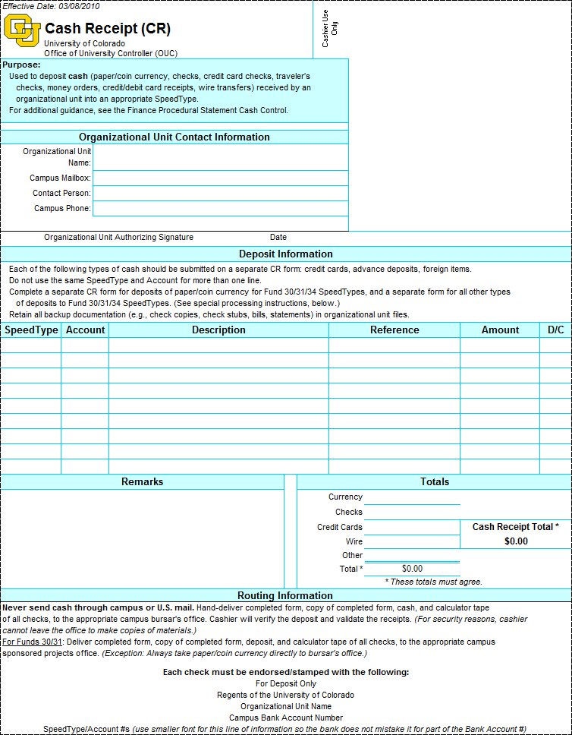

CASH DISBURSEMENTS
Cash is paid out from the University as a means of achieving the goals of the university. Examples of cash paid out from the university include:
    - Transactions processed through Payroll by PBS
- Transactions processed through Accounts Payable at the PSC
- Vending machine change through departmental change funds
- Demand warrants through the Bursar’s office.

PeopleSoft Finance System Effect
Every payroll and accounts payable cash disbursement transaction is preceded with an accrual transaction. The accrual transaction generates a credit to a liability account on the balance sheet, and a debit to the SpeedType-Account combination designated on the source document. The cash disbursement transaction is processed subsequent to the accrual transaction which results in a debit to the liability account entered on the accrual transaction and a credit to the cash account on the respective balance sheet.

On every cash disbursement transaction, a SpeedType-Account combination is indicated to record the charge (debit). The transaction then appears on the monthly Revenue and Expense Statement Detail. It is the department’s responsibility to reconcile all detail from the source record/document for the disbursement to the information appearing on the PeopleSoft Finance System monthly detail statement. This includes verifying that
  - The transaction amount was accurately recorded
  - The transaction was appropriately entered as a debit (or rarely, as a credit)
  - The correct SpeedType-Account combination (the one coded on source record/document) was used.

Contact your Campus Controller’s Office for assistance with understanding the disbursement information appearing on the monthly financial statements.

Overages/Shortages
Maintain a record of all over (short) balances. This should be included on the daily cash balancing forms using account 552630 – Cash Over/Short.

CHANGE FUND
A change fund is an amount of money advanced to departments that accept cash from customers and, therefore, must have cash available to make change. Change funds may be issued on either a temporary basis (for a specific activity or event) or on a permanent basis (for ongoing departmental business.)
Change funds are established in dollar amounts appropriate to business needs not to exceed $100,000.

Change funds must always equal the total authorized amount, which is the amount approved by your Campus Controller’s Office. The change fund is subject to unannounced audits at any time by your Campus Controller’s Office, internal auditors, and external auditors.

Proper Use of Change Funds
Change funds are used exclusively to make change when receiving cash, for example, from fees, fines, or sales. No expenses of any kind may be authorized from a change fund.

Establishing a Change Fund
The change fund must be requested by the individual, known as a custodian. The custodian is the individual designated by the campus controller as responsible for safeguarding and disbursing from the change fund. The custodian must be a university employee with a 50% or greater appointment or affiliate fiscal staff and must be authorized by the department head and the Campus Controller’s Office.

To establish a change fund, complete a Petty Cash/Change Fund Request (PCCF) form. An example appears on the last page of this chapter. In addition, complete a Payment Voucher for the amount requested for the change fund. Both forms are available on the PSC Forms webpage.

On the Payment Voucher:
- Make payable to the custodian (e.g. John Doe, Petty Cash Custodian)
- Use your departmental address (campus box)
- Enter “to establish new change fund” in the Description field
- Use Account 000300 (Change Fund)
- Include the reason for opening the fund in the Business Purpose section—the same explanation used on the PCCF form.

A partially completed Payment Voucher example appears below that highlights these bulleted points.

How to fill out the PV for a new Change Fund
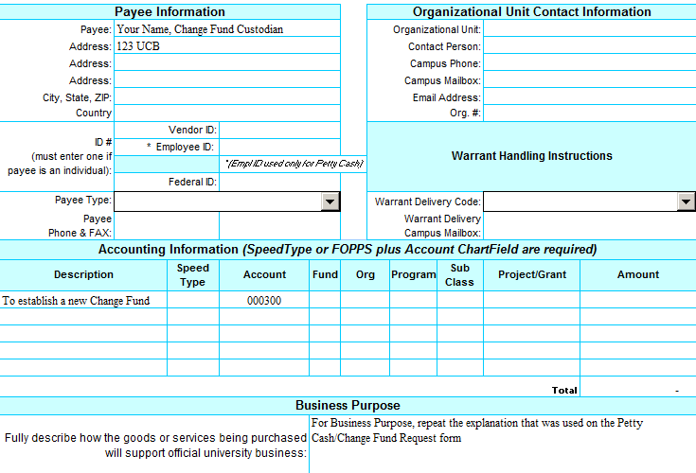
Custodian’s name followed by “Change Fund Custodian”
Use your campus box number
(disregard the pop-up message)
Complete all the regular PV fields. Those highlighted here are just to draw your attention to out-of-the-ordinary requirements.

Submit both original PCCF and PV forms to your Campus Controller’s Office. Your Campus Controller’s Office will return an approved copy of the PCCF form to the custodian, and submit the original PCCF and Payment Voucher to the PSC for processing. The PSC then sends a check to the custodian at the departmental address listed on the Payment Voucher. The custodian may cash the check at the Cashier’s window in Regent Hall. Note: The custodian must show picture identification at the Cashier’s window. See Check Cashing Tips on page 21.

Using and Maintaining a Change Fund
- The custodian must take appropriate measures to ensure the security of the change fund at all times. Examples include, but are not limited to:
- Keeping the change fund in a locked cash drawer or cash register,
- Restricting access to the change fund to only the assigned custodian.
- At the end of the day, or at the end of the employee’s shift when the change fund has been used, verify that the fund equals the total authorized amount. Note: Any overage or shortage due to errors must be recorded to account 552630 – Cash Over/Short.
- If a theft occurs, notify the Campus Police Department and your Campus Controller’s Office as soon as the theft is discovered. Campus Police will investigate and complete a report. Prepare a Payment Voucher for the amount of the theft. The PV should be drawn against the change fund SpeedType, account 552630 – Cash Over/Short. Attach a copy of the police report to the PV and submit these materials to the PSC. A check to reimburse the change fund will be issued to the custodian. Note: If the theft or loss is determined to be due to the negligence of the custodian, the department head may choose to require the custodian to replace the funds.
- A new PCCF must be submitted for the any of the following occurrences:
- Custodian changes
- Increase or decrease in authorized amount
- Closing the fund
For a change in fund location, a PCCF is not needed. However, inform your Campus Controller’s Office of the the new location.
- Consider designating a “back-up” to manage the change fund in the event of an absence in order to be able to continue using the change fund when the custodian is away. Prepare a memo that delegates this authority from the custodian to the back-up, signed by both parties. It should include a cash count.
- Increases to existing change funds must be requested and processed in the same manner as the establishing a change fund with a PCCF and PV.
- Partial returns (reductions) of the authorized amount must be made by deposits into the SpeedType from which it was advanced using account 000300. After depositing the cash, the custodian must provide the Campus Controller’s Office with a validated copy of the Cash Receipt from the Cashier and a PCCF. The Campus Controller’s Office will sign the PCCF and provide a copy to the custodian and send copies to the PSC, thus officially releasing the custodian of the responsibility for the amount of the partial return. Until this is done, the custodian remains responsible for the original total authorized amount.

Closing a Change Fund
When the change fund is no longer needed, it should be closed.
- Count the fund to verify that it contains the authorized amount. Correct any variance using account 552630 – Cash Over/Short and Cash Receipt or PV as required.
- The designated individual within the department prepares and deposits a Cash Receipt for the full change fund amount. The Cash Receipt should identify the speedtype associated with the fund, and Account 000300.
- Send a validated copy of the Cash Receipt with a new PCCF to close the Change Fund to your Campus Controller’s Office in order to clear the custodian of the responsibility.
- The Campus Controller’s Office updates the PCCF form on file by checking the Close Fund checkbox and sends copies of the updated form to the PSC and to the former custodian, thereby releasing the latter from any responsibility for this fund.

PETTY CASH FUND
A petty cash fund is an amount of money issued to a department used on a revolving basis for the payment of incidental expenses of a nominal amount and that are not appropriately billed by invoice and paid by voucher or warrant. Consider the use of petty cash to make purchases as an exception to the university’s standard procurement methods. The Procurement Card is the preferred method to make small dollar purchases. Alternately, departments can identify frequently used vendors and consider setting up standing purchase orders with those vendors through the PSC.

Petty cash funds are generally limited to less than $500 per department, but in no case can it exceed $5,000 issued to a single custodian. The actual authorized amount is determined by operational needs. Each speedtype can have only one petty cash fund. Those using restricted Funds (30, 31, and 34) may only be used to benefit the restricted purpose. With the exception of University Physicians Incorporated (UPI), agency Fund 80 cannot establish petty cash funds.

Petty cash used for study subject payments should be established exclusively for this purpose. See the Study Subject Payments section below.

Proper Use of Petty Cash Funds
Petty cash funds must be used only to purchase incidental items of a nominal amount for which other established university procurement methods are not feasible. Nominal currently means $60 for study subject payments and $25 for all other expenses. See the Study Subject Payments section below for exceptions.

Petty cash funds may only be used for the intended purpose as set forth in the Petty Cash/Change Fund Request (PCCF) form for purchases as allowed by university policy. Petty cash funds may not be used for the following:
- Alcoholic beverages for personal consumption
- Cashing personal checks
- Employee reimbursements
- Flowers, coffee, or other personal consumable items
- Honoraria payments
- Items purchased for resale (e.g. buying & selling stamps to employees)
- Official functions
- Payments to other university departments (use an Interdepartmental Order (IN) form)
- Payroll expenses (done through Payroll & Benefits Services)
- Personal loans to faculty, staff, students or others—no IOUs
- Services (other than human subject payments)
- Student awards
- To open accounts at banks or other financial institutions
- Travel expenses (except parking/transportation services at a university site for non-employees)

Campus Controller’s Office approval is required before purchasing cash-like items such as gift cards, gift certificates, and money orders.

Memorandum Receipts
Normally, the fund custodian makes purchases and obtains the original receipts to support the expenditure. In addition, cash may be advanced to employees for the purpose of making a purchase for official university business. This advance must be documented by use of a memorandum receipt with the date of the advance, a description of what will be purchased, the signature of the person accepting the cash, and the date by which the receipt and any unused cash will be returned to the custodian. The receipt for the purchase and all unused cash is returned to the custodian by the due date.

Study Subject Payments made with Petty Cash
The department must maintain documentation to support the petty cash fund disbursements. There is a confidentiality distinction between study subjects (non-confidential) and health-related/human subject (confidential). This determines how records are kept and how payments are processed and is covered below in Section D. For discussion purposes, the term subject payment includes both groups.
Subject payments may be made from a petty cash fund if Payment Vouchers or other more secure forms of payment are not a practicable form of payment. Petty cash funds established for subject payments may be authorized for amounts up to $5,000. Preferably, each sponsored project that requires subject payments shall have one petty cash fund set up exclusively for this purpose. The Principal Investigator (PI) or the PI’s designee shall be the custodian. Custodians for these subject payment petty cash funds must be university employees but may hold less than a 50% appointment. Petty cash funds for subject payments are normally set up in the speedtype to which the subject payment expenses are recorded. Generally this is the Fund 30/31 project itself. A project is limited to a single petty cash fund.

If a PI has multiple projects that require subject payments, it is permissible to set up a petty cash fund in each Fund 30/31 project with the same custodian, provided the total of all petty cash funds for that custodian does not exceed $5,000. Petty cash funds set up in Fund 30/31 projects may not be commingled with other funds or used to pay subjects in other projects.

Petty cash funds set up for subject payments are limited to subject payments and cannot be used to pay for other types of expenses. Record subject payments using account code 495102–Study Subjects.

Subject payments may also be made from a general departmental petty cash fund in lieu of setting up a petty cash fund expressly for subject payments if this purpose was identified when the fund was initially established. This option is allowable only for studies that involve occasional or a small number of payments. However, the authorized amount of a general departmental petty cash fund cannot be increased to accommodate the addition of subject payments. If additional funds are needed, a separate dedicated petty cash fund should be established for this purpose. A petty cash fund to pay study subjects on behalf of multiple sponsored projects may also be set up in a Fund 29.

Subject payments made during travel or extended stays in remote locations may be made using cash supplied from a Travel Advance or Remote Stay Fund processed through the PSC Travel Authorization Program.

Payments to study subjects are considered compensation for time and inconvenience and are taxable to the recipient. When payments to an individual reach $600 or more during a calendar year, the University is required to file an IRS Form 1099-MISC. The department is responsible for collecting and reporting this payment information and submitting a completed CU Vendor Authorization and W-9 form to the PSC for those study subjects who have reached the $600 threshold.

Establishing a Petty Cash Fund
The petty cash fund must be requested by the individual, known as a custodian. The custodian is the individual designated by the campus controller as the one responsible for safeguarding, disbursing from, and requesting replenishment of, a petty cash fund. The custodian must be a university employee with a 50% or greater appointment or affiliate fiscal staff and must be authorized by his or her department head and by the Campus Controller’s Office.

To establish a petty cash fund, complete a Petty Cash/Change Fund Request (PCCF) form. An example appears on the last page of this chapter. In addition, complete a Payment Voucher for the amount requested for the fund. Both forms are available on the PSC Forms webpage.

On the Payment Voucher:
- Make payable to the custodian (e.g. John Doe, Petty Cash Custodian)
- Use your departmental address (campus box)
- Enter “to establish new petty cash fund” in the Description field
- Use Account 000200 (Petty Cash)
- Include the reason for opening the fund in the Business Purpose section—the same explanation used on the PCCF form.

How to fill out the PV for a new Petty Cash Fund
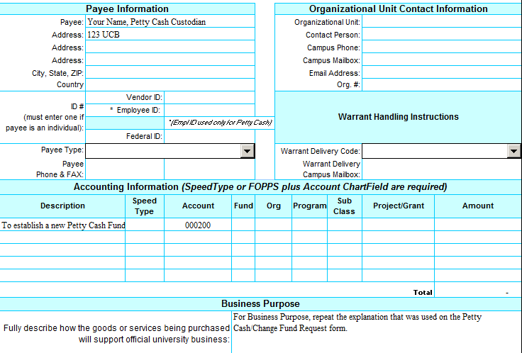
Custodian’s name followed by “Petty Cash Custodian”
Use your campus box number
(disregard the pop-up message)
Complete all the regular PV fields. Those highlighted here are just to draw your attention to out-of-the-ordinary requirements.
Submit both original PCCF and PV forms to your Campus Controller’s Office. Your Campus Controller’s Office will return an approved copy of the PCCF form to the custodian, and submit the original PCCF and Payment Voucher to the PSC for processing. The PSC then sends a check to the custodian at the departmental address listed on the Payment Voucher. The custodian may cash the check at the Office of Cash Management (OCM)/Bursar’s Office cashier’s window. If you decide that you don’t want to cash the check and want to return it (e.g. you want to close the petty cash fund) endorse it and submit it with a cash receipt to OCM/Bursar’s Office to deposit it back to the petty cash SpeedType.
Check Cashing Tips:
Petty cash and change fund checks can be cashed at the Office of Cash Management (OCM)/Bursar’s Office, but keep the following in mind: If you require multiple denominations and rolled coins, please call in advance, to make sure the funds are on hand before you go. For checks over $300, call in advance especially if small denominations are needed. Plan to arrive before the last hour of business. Bring a government issued photo ID or Buff One card (and properly executed letter of authorization if used**). Bring checks over in a locked bag in which to place the cash for transport.
**A letter of authorization can be used if the petty cash custodian is not the person coming to cash the check. The letter should be on letterhead and identify the person coming to cash the check on behalf of the custodian. The custodian needs to endorse the check and put his/her employee ID number in the endorsement area. OCM/Bursar’s Office verifies the government issued ID card of the runner and keeps the authorization letter.

Controlling the Petty Cash Fund
The responsibility for security of the petty cash rests with the custodian of the fund. The custodian must take appropriate measures to ensure the petty cash fund and unreimbursed receipts are safe and secure at all times, including:
- Keep the petty cash locked up.
- Restrict access to the petty cash fund only to the custodian.
- Obtain signed memorandum receipts for any petty cash issued to an individual to make a purchase.
- Obtain receipts and/or unused cash issued to make a purchase in a timely manner.
The petty cash fund must be counted at least weekly to verify that it is intact. The total cash on hand, plus receipts on hand, plus cash signed for, plus Payment Vouchers in process for reimbursement must add up to the total authorized amount.
If the petty cash fund is found to be short due to an error, prepare a Payment Voucher as a charge against the petty cash SpeedType, account code 552630 – Cash Over/Short. If the shortage is more than 10% of the fund amount, your Campus Controller’s Office must review and approve the PV. If the petty cash fund is found to be over due to an error, then the overage should be deposited to the petty cash SpeedType, account code 552630 using a Cash Receipt. If the overage is more than 10% of the fund amount, your Campus Controller’s Office must also sign the Cash Receipt.

If a theft occurs, notify the Campus Police Department and your Campus Controller’s Office as soon as the theft is discovered. Campus Police will investigate and complete a report. Prepare a Payment Voucher for the amount of the theft. The PV should be drawn against the petty cash fund SpeedType, account 552630 – Cash Over/Short. Attach a copy of the police report to the PV and submit these materials to the PSC. A check to reimburse the change fund will be issued to the custodian. Note: If the theft or loss is determined to be due to the negligence of the custodian, the department head may choose to require the custodian to replace the funds.

For internal control purposes, someone other than the custodian should participate in the monthly statement review process with particular emphasis on petty cash expenditures. The petty cash fund is subject to unannounced audits at any time by your Campus Controller’s Office, internal auditors, and external auditors.

Using and Replenishing the Petty Cash Fund
Before it gets too low to serve the business needs of the department, replenish the petty cash fund by submitting a PV to the PSC. Allow enough time and cash on hand for the PV to be processed. At a minimum, replenish the fund:
- at least once per quarter; as well as,
- at the end of the fiscal year (June);
- any time the designated custodian changes; and,
- any time a shortage is detected.
The PSC compares custodian and fund amount on the PV with information in the PSC’s database of authorized custodians and their authorized fund amounts. If the information does not match, the PV is not processed and the PSC will contact the custodian. Replenishment procedures are outlined below.
- If several petty cash funds need to be replenished at the same time, submit a separate PV for each petty cash fund.
- On the PV, the payee must be the designated custodian, e.g., Daddy Warbucks, Petty Cash Custodian (you must include the phrase Petty Cash Custodian following the custodian’s name).
- The payee address must be the departmental address and not the custodian’s home address.
- The requestor must be the custodian. This individual must sign the PV form. This individual cannot approve the form.
- Use an Account that best represents the type of expense incurred. Use the speedtype that most appropriately covers that expense.
- All receipts must be attached to the PV. The dollar amounts on the receipts must exactly match the dollar amounts requested for replenishment. Documentation must include:
      - transaction date (date the cash was disbursed)
      - payee, i.e. name of recipient (for confidential study subject payments see box below)
      - recipient signature (for confidential study subject payments see box below)
      - quantity
      - description of items purchased
      - cost of each item
      - total dollar amount of cash disbursed to recipient
      - official university business purpose
      - note the speedtype to be charged for the expense.

If this information is not provided by the vendor on the receipt, then the purchaser should note this information on the face of the receipt.
Cash the reimbursement check at the OCM/Bursar’s Office Cashier’s window.

Confidential Study Subject Payments
In order to protect privacy, petty cash fund used to pay participants in confidential human subject studies should use the following procedures:
■ Assign case/client reference numbers to participants in such a way that anonymity is maintained (i.e. don’t use personal identifiers as part of the #).
■ Have the subject sign the payment receipt (or log if used—see sample log).
■ Keep the receipt/log securely in the department.
■ Submit documentation with the Payment Voucher that shows the research control numbers, amount paid, and date. The control numbers must tie to the participant names but do not submit signed receipts or names to the PSC.
■ The business purpose field on the PV should be completed with information that this is a petty cash fund reimbursement used to pay confidential human subjects with the date (or date range) of the payments.

Modifying a Petty Cash Fund
A new PCCF must be submitted for the any of the following occurrences.
- Custodian changes
- Increase or decrease in authorized amount
- Closing the fund
For a change in fund location, a PCCF is not needed. However, inform your Campus Controller’s Office of the the new location.

Changing the Custodian
Whenever a change in custodian is required, the fund must first be replenished completely. The new custodian then completes a new PCCF form and submits the original form to the Campus Controller’s Office. Until this is done, the previous custodian maintains responsibility for the petty cash fund.

Increasing the Authorized Amount
Increases to existing petty cash funds are requested and processed in the same manner as establishing a new fund using a PCCF and PV form.

Decreasing the Authorized Amount
A petty cash fund should be reduced if the full amount is no longer needed. Partial returns (reductions) of the authorized amount must be made by deposits into the SpeedType from which it was advanced using account 000200. After depositing the cash, the custodian must provide the Campus Controller’s Office with a validated copy of the cash receipt and a PCCF. The Campus Controller’s Office will sign the PCCF and provide a copy to the custodian and send copies to the PSC, thus officially releasing the custodian of the responsibility for the amount of the partial return. Until this is done, the custodian remains responsible for the original total authorized amount.

Closing a Petty Cash Fund
When the petty cash fund is no longer needed, it should be closed.

- Submit a final PV to the PSC to replenish the petty cash fund for all outstanding final expenses (read step 2 before submitting PV).
- Count the fund to verify that it contains the authorized amount. Correct any variance using account 552630–Cash Over/Short and a Cash Receipt or a PV as required. (Note: do this step before submitting the PV in Step 1 so that a shortage can be processed with the same PV.)
- The designated individual within the department prepares and deposits a Cash Receipt for the full petty cash fund amount. The Cash Receipt should identify the speedtype associated with the fund, recorded in Account 000200 (Petty Cash Fund).
- Send a validated copy of the Cash Receipt with a new PCCF to close the Petty Cash Fund to your Campus Controller’s Office so that the custodian can be cleared of the responsibility.
- The Campus Controller’s Office updates the PCCF form on file by checking the Close Fund checkbox and sends copies of the updated form to the PSC and to the former custodian, thereby releasing the latter from any responsibility for this fund.

Revocation of a Petty Cash Fund
Continued violation of these polices and procedures will subject the petty cash fund to revocation by the campus controller.

Petty Cash/Change Fund Request Form
Available from PSC Forms webpage

