CHAPTER 7
TABLE OF CONTENTS

I. CHAPTER PURPOSE 2
II. PERTINENT GUIDELINES AND REGULATIONS 2
A. GAAP 2
B. Higher Education Financial Reporting GAAP 4
III. DAY-TO-DAY OPERATIONAL STRUCTURE 5
IV. UNRESTRICTED VS. RESTRICTED 6
V. FUND AND FUND GROUPS 8
A. Fund 8
B. Fund Group 9
VI. AGENCY FUNDS (Fund 80) 10
VII. PLANT FUNDS (Funds 71, 72, 73, 74, 78) 11
A. Capital Construction Plant Fund (Fund 71) 12
B. Renewal and Replacement Plant Fund (Funds 72, 78) 12
C. Retirement of Indebtedness Plant Fund (Fund 73) 13
D. Investment in Plant Fund (Fund 74) 14
VIII. LOAN FUNDS (Fund 50) 14
IX. CURRENT FUNDS (Funds 10, 11, 20, 26, 28, 29, 30, 31, 34) 14
A. General Fund (Fund 10) 15
B. ICR Fund (Fund 11) 15
C. Auxiliary TABOR Enterprise Fund (Fund 20) 15
History and Overview of TABOR 17
D. Auxiliary Other Exempt Fund (Fund 26) 20
E. Auxiliary Internal Service Center Fund (Fund 28) 20
F. Auxiliary Non-Enterprises Fund (Fund 29) 20
G. Sponsored Projects Fund (Funds 30, 31) 21
H. Gift Fund (Fund 34) 21
XI. EDUCATIONAL & GENERAL FUNCTIONS (EPC CODES) 21
A. Instruction (EPC 1100) 21
B. Research (EPC 1200) 22
C. Public Service (EPC 1300) 22
D. Academic Support (EPC 1400) 23
E. Student Services (EPC 1500) 23
F. Institutional Support (EPC 1600) 24
G. Operation of Plant (EPC 1700) 24
H. Scholarships and Fellowships (EPC 1800) 25
I. Internal Service Centers (EPC 2100) 26
J. Non-ISC Sales between Departments 28
1. Internal Service Center Sales (IN) 28
2. Auxiliary Enterprise Interdepartmental Sales 28
3. Other Interdepartmental Revenue (ID) 28
XII. TRANSFERS 29
A. Mandatory Transfers 30
B. Voluntary Transfers 30
C. Restrictions on Transfers 30

XIII. ATTACHMENTS 31
Attachment A – Sample Audit Guide Statements 33
Attachment B – Statement of Net Assets 40
Attachment B – Statement of Net Assets - Continued 41
Attachment B – Statement of Revenues, Expenses, and Changes in Net Assets 42
Attachment B – Statement of Revenues, Expenses, and Changes in Net Assets - Continued 43
Attachment B – Statement of Cash Flows 44

CHAPTER PURPOSE
The purpose of this chapter is to provide an overview of the fundamentals for the higher education basic fund accounting and financial reporting structure required by Generally Accepted Accounting Principles (GAAP) and to which the University is audited. This will provide a context for understanding how the PeopleSoft Finance System general ledger and chart of accounts are set up to meet these requirements, and why it is necessary to do certain things in University accounting.

PERTINENT GUIDELINES AND REGULATIONS

GAAP
The University of Colorado’s (CU) independent auditor’s unqualified opinion for fiscal year ended 2010 reads: update per 2011

In our opinion, based on our audit and the reports of the other auditors, the financial statements referred to above present fairly, in all material respects, the respective financial position of the business-type activities and the aggregate discretely presented component units of the University of Colorado as of June 30, 2010, and the respective changes in financial position and cash flows, where applicable, thereof for the year then ended, in conformity with accounting principles generally accepted in the United States of America.

Generally accepted accounting principles (GAAP) is a technical accounting term that encompasses the conventions, rules, and procedures necessary to define accepted accounting practice at a particular time. Those conventions, rules, and procedures provide a standard by which to measure financial presentation.

The Governmental Accounting Standards Board (GASB) is the independent, not-for-profit organization formed in 1984 that establishes and improves financial accounting and reporting standards for state and local governments, including public universities. In March 2009, GASB issued Statement No. 55, The Hierarchy of Generally Accepted Accounting Principles for State and Local Governments. The Statement incorporates the hierarchy GAAP for state and local governments into the GASB’s authoritative literature. Prior to GASB Statement 55, the GAAP hierarchy was set forth in the American Institute of Certified Public Accountants’ (AICPA) Statement on Auditing Standards (SAS) No. 69, The Meaning of Present Fairly in Conformity With Generally Accepted Accounting Principles, rather than in the authoritative literature of the GASB. Statement 55 moves relevant portions of that SAS to the GASB literature without substantive changes.

The conventions, rules, and procedures applicable to CU are comprised of authoritative guidance from various sources such as the GASB, the American Institute of Certified Public Accountants (AICPA), the Financial Accounting Standards Board (FASB), the National Association of College and University Business Officers (NACUBO), etc. Each of these organizations issues various documents with differing levels of authority such as official statements, interpretations, implementation guides, accounting standards, etc. Statement 55 provides a GAAP Hierarchy establishing the priority of these documents so that we know what level of importance to place on each. The Statement 55 GAAP Hierarchy Summary in priority order for state and local governments, including public institutions of higher education, is:

- Officially established accounting principles consisting of GASB Statements and Interpretations.
- GASB Technical Bulletins and, if specifically made applicable to state and local governmental entities by the AICPA and cleared by the GASB, AICPA Industry Audit and Accounting Guides, and AICPA Statements of Position.
- AICPA Practice Bulletins if specifically made applicable to state and local governmental entities and cleared by the GASB, as well as consensus positions of a group of accountants organized by the GASB that attempts to reach consensus positions on accounting issues applicable to state and local governmental entities. (As of the date of the Statement, such a group had not been organized.)
- Implementation guides (Q&As) published by the GASB staff, as well as practices that are widely recognized and prevalent in state and local government.
- Other accounting literature including GASB Concepts Statements; pronouncements referred to in the above categories of the GAAP hierarchy for nongovernmental entities if not specifically made applicable to state and local governmental entities by the GASB; FASB Concepts Statements; Federal Accounting Standards Advisory Board (FASAB) Statements, Interpretations, Technical Bulletins, and Concepts Statements; AICPA Issues Papers; International Public Sector Accounting Standards of the International Public Sector Accounting Standards Board or International Financial Reporting Standards of the International Accounting Standards Board, or pronouncements of other professional associations or regulatory agencies; Technical Information Service Inquiries and Replies included in AICPA Technical Practice Aids; and accounting textbooks, handbooks, and articles. The appropriateness of other accounting literature depends on its relevance to particular circumstances, the specificity of the guidance, and the general recognition of the issuer or author as an authority. For example, GASB Concepts Statements would normally be more influential than other sources in this category.

Higher Education Financial Reporting GAAP
For CU, GASB Statement No. 15, Governmental College and University Accounting and Financial Reporting Models sets the basic financial statement model through June 30, 2001 (fiscal year 2001). Under the authority of this Statement, the State Controller elected to have Colorado institutions follow the AICPA Industry Audit Guide, Audits of Colleges and Universities, as amended by AICPA Statement of Position (SOP) 74-8, Financial Accounting and Reporting by Colleges and Universities. The Audit Guide was originally issued in 1973. It was updated in 1975 to incorporate SOP 74-8. The last update was issued in 1992 to include conforming changes as of May 1, 1992. The Audit Guide required three basic financial statements to be presented in a “fund group” perspective. See Attachment A for the Audit Guide illustrative statements.

- Balance Sheet (Attachment A, Exhibit 1)
- Statement of Changes in Fund Balance (Attachment A, Exhibit 2)
- Statement of Current Funds Revenue, Expenditure, and Other Changes (Current Funds Statement) (Attachment A, Exhibit 3)

The primary purpose of the Statement of Current Funds Revenue, Expenditure and Other Changes is to provide the detail behind the summarized figures on the Statement of Changes in Fund Balance.

GASB Statement No. 35, Basic Financial Statements—and Management’s Discussion and Analysis—for Public Colleges and Universities was issued in November 1999 and supersedes GASB Statement No. 15. Statement No. 35 directs public colleges and universities to follow GASB Statement No. 34, Basic Financial Statements—and Management’s Discussion and Analysis—for State and Local Governments. These two statements are supplemented by the GASB Statement No. 34 Implementation Guide and the NACUBO Statement No. 35 Implementation Guide. This change is applicable to fiscal year 2002 (ended June 30, 2002) and subsequent years. Statements 34/35 require the following basic financial statements to be presented on the “entity-wide” perspective rather than the Audit Guide’s “fund group” perspective. See Attachment B for the Statement 35 illustrative statements.
- Statement of Net Assets (SNA) (Attachment B, Exhibit 1)
- Statement of Revenue, Expenses and Changes in Net Assets (SRECNA) (Attachment B, Exhibit 2)
- Statement of Cash Flows (Cash Flows) (Attachment B, Exhibit 3)

DAY-TO-DAY OPERATIONAL STRUCTURE
Public colleges and universities receive resources from a variety of sources that restrict the use of the resources. These include grants and contracts from sponsors, and gifts from donors. State legislative processes also appropriate state funds to an institution. Legislators and taxpayers want to know how these funds are used to accomplish the institution’s mission and to be assured that these funds are used in accordance with any appropriation requirements. Additionally, the governing board (management) of the institution will designate resources to be used for certain purposes such as student loans or capital construction. Some operations of the institution, such as Housing, are required to generate revenue sufficient to cover all of their operating expenses and debt payments. This financial environment of public colleges and universities imposes upon higher education a special stewardship obligation to be able to demonstrate that all resources were recorded and used in accordance with the directives of the outside sources providing the resources. This stewardship obligation requires an accounting system that provides for the unique identification and recording of individual resources so that they are not commingled with other resources.

Higher education accounting systems are traditionally based on a “fund accounting” structure. The Audit Guide ¶2.02 defines fund accounting as the procedure by which resources for various purposes are classified for accounting and reporting purposes in accordance with regulations, restrictions, or limitations imposed by sources outside the institution, or in accordance with directions issued by the governing board. ¶2.03 defines a fund as an accounting entity with a self-balancing set of accounts for recording assets, liabilities, a fund balance and changes in the fund balance (revenue, expense and cash transfers). Separate accounts are maintained for each fund to ensure observance of limitations and restrictions placed on the use of resources. For accounting and reporting purposes, however, “funds of similar characteristics” are combined into “fund groups.” ¶2.05 identifies the fund groups usually encountered in an educational institution:
- Current funds
- Loan funds
- Endowment and similar funds
- Annuity and life income funds
- Plant funds
- Agency funds.

While Statements 34 and 35 change the external reporting orientation from the Audit Guide’s fund group perspective to the entity-wide perspective, the University is still required to use its traditional fund accounting system to meet its stewardship obligations. Additionally, the use of the traditional fund groups serves management’s needs to plan and manage the financial activity of the institution. Finally, while Statements 34 and 35 change the overall format of the basic financial statements, they do not define the categories of revenue and expense. However, their illustrative statements do use most of the same revenue and expense categories as those presented in the Audit Guide. So, while the Audit Guide is technically no longer GAAP, the University must still turn to it to define funds, fund groups, revenues, expenses and cash transfers that are used in the CU accounting system and in its day-to-day operations. The good news is that while Statements 34 and 35 represent one of the largest changes in higher education financial reporting history, they have minimal impact on how departments do their day-to-day accounting in the Finance System. The biggest impact is on the year-end entries that your campus controller’s office makes to offset some of the traditional day-to-day operational entries in order to present the University’s financial statements on the Statements 34 and 35 entity-wide basis.

The discussion now turns to an analysis of the Audit Guide and how the Finance System is structured to fulfill the Audit Guide requirements.

UNRESTRICTED VS. RESTRICTED
All resources of an institution are initially classified as either unrestricted or restricted. This concept is applied to all of the fund groups.

The Audit Guide Statement of Position (SOP) defines this concept under Current Funds.

The Current Funds group has two basic subgroups—unrestricted and restricted. Unrestricted current funds include all funds received by the institution for which no stipulation was made by the donor or other external agency as to the purposes for which the funds should be expended. Restricted current funds are those available for financing operations, but which are limited by donors or other external agencies to specific purposes, programs, departments, or schools. Externally imposed restrictions are to be contrasted with internal designations imposed by the governing board on unrestricted funds. Internal designations do not create restricted funds, inasmuch as the removal of the designation remains at the discretion of the governing board.

The distinction between unrestricted and restricted funds is maintained through the use of separately balanced groups of accounts in order to provide acceptable reporting of stewardship to donors and other external agencies. This distinction also emphasizes to governing boards and other sources of financial support the various kinds of resources of the Current Funds group that are available to meet the institution’s objectives.

Separate accounting entities may be provided for auxiliary enterprises, hospitals, and independent operations in either the Unrestricted Current Funds or the Restricted Current Funds subgroup or both, as appropriate.

The first question to ask about every revenue dollar is whether it is an unrestricted or restricted resource. For example, has the resource provider limited the institution’s use of the funds for a specific purpose such as financial aid, a specific program such as a sponsored project or a capital construction project, a specific department, a specific school, or a specific campus?

A good test to use in determining whether or not revenue is restricted is to ask if the resource provider has the right to object and demand a return of the funds if the University were to use the funds, for example, to pay the salary of an accountant at the Anschutz Medical Campus. If the answer is yes, then these funds are restricted in some way and therefore are restricted funds. If the answer is no, and the Board of Regents is free to direct the use of the funds for any legal purpose, then these are unrestricted funds.

If the restrictions are such that the funds can only be used for Loan Fund or Plant Fund purposes, then the funds must be reported as revenue of those respective fund groups. It is inappropriate to report funds with loan fund or plant fund purpose restrictions as revenue of the current funds (with a cash and fund balance transfer to the other funds), since according to the restrictions these funds are not available to fund current operating expenses.

The concept of unrestricted vs. restricted funds is critical and carries through into the Net Asset section of the GASB 34 and 35 entity-wide Statement of Net Assets.
NET ASSETS
Invested in capital assets, net of related debt
Restricted for:
Nonexpendable:
Expendable:
Unrestricted

Although these are entity-wide perspective statements, there is still a certain amount of fund accounting carried over in order to provide these categories of net assets.

The mandate to maintain restricted funds separately from unrestricted funds prohibits the University from doing cash transfers between these funds.

FUND AND FUND GROUPS
As discussed in the previous sections of this chapter, the focus of the Audit Guide and a fund accounting system is the proper classification of resources, or revenue. Therefore, the key to higher education fund accounting is a thorough understanding of the proper accounting for all revenues. Once the revenue is properly accounted for in the correct fund, and therefore in the correct fund group, then the expenditure of that revenue naturally follows.

Fund
The first building block of a fund accounting system is defining what constitutes a fund. Remember, the Audit Guide ¶2.03 defines a fund as an accounting entity with a self-balancing set of accounts for recording assets, liabilities, a fund balance and changes in the fund balance (revenue, expense, and cash transfers).

In the PeopleSoft Finance System a fund is a unique combination of the three ChartFields of either the fund/organization/program or the fund/organization/project. Each unique combination is most commonly referred to as a “FOPP” or “FOPPS,” but can also be referred to as a combo, SpeedType, or fund. Each of these unique FOPPS is a fund set up to account for a unique activity’s resources and use of those resources, separate from the accounting for all other resources and activities of the University. Each FOPPS then uses the accounts from the Chart of Accounts to classify the assets, liabilities, fund balance, revenues, expenses, and cash transfers of that fund. The revenue, expenses and cash transfers are used to report the change in fund balance of that FOPPS from one period to the next. Each FOPPS is a self-balancing set of records for that unique activity’s financial transactions.

A FOPPS is set up when required by provider restrictions such as for each sponsored project or gift, or when desired to uniquely account for the allocation of unrestricted resources for a designated purpose such as general operations. The resources of the FOPPS can be a budget allocation, revenue, a cash (and fund balance) transfer in, or a combination of these.

Fund Group
The second building block is to define the purpose of each fund group and to identify each fund to its proper fund group. The Audit Guide illustrative statements (Attachment A, Exhibits 1, 2, 3) present the following fund groups and subgroups.
- Current funds
- Unrestricted
- Restricted
- Loan funds
- Endowment and similar funds
- Annuity and life income funds
- Annuity funds
- Life income funds
- Plant funds
- Unexpended
- Renewals and replacements
- Retirement of indebtedness
- Investment in plant
- Agency funds

CU uses the PeopleSoft Finance System Fund ChartField to identify its fund groups and thereby assign each FOPPS to the proper fund group or subgroup.

The next section will focus on the fund groups used by CU:

- Current Funds
- Loan Funds
- Plant Funds
- Agency Funds.

All endowments (Fund 60) are accounted for at the system level and not at the campus level. Thus, endowments are not included in this discussion.

The following table shows how the PeopleSoft Finance System funds are identified to the Audit Guide fund groups and how the PeopleSoft Finance System funds are grouped under the CU financial statements fund groups.

Audit Guide and Finance System Structure | Financial Statement Fund Group
Current Funds
Unrestricted
10 – General Fund | State Appropriated Funding
11 – ICR (Indirect Cost Recovery) | State Appropriated Funding
20 – Auxiliary TABOR Enterprises | Auxiliary & Self-funded Activities
26 – Auxiliary Other Exempt | Auxiliary & Self-funded Activities
28 – Auxiliary Internal Service Centers | Auxiliary & Self-funded Activities
29 – Auxiliary Non-Enterprises | Auxiliary & Self-funded Activities
Restricted
30 – Grants and Contracts | Restricted Fund
31 – Grants and Contracts | Restricted Fund
34 – Gifts | Restricted Fund
Loan Funds
50 – Loan Funds | Student Loan Funds
Plant Funds
71 – Capital Construction | Unexpended
72 – General Fund Renewal & Replacement | Unexpended
78 – Auxiliary Renewal & Replacement | Unexpended
73 – Retirement of Indebtedness | Retirement of Indebtedness
74 – Investment in Plant | Investment in Plant
Agency Funds
80 – Agency Funds | Restricted Fund

In addition to these funds, CU also has Fund 99: GASB 34-35 Reporting. This fund is used solely for entries to adjust the Audit Guide fund group perspective into the GASB 34/35 entity-wide perspective. Most of these entries arise from showing activities between the various fund groups that would result in inflating revenues and expenses if they were not offset. Examples are:
- Unrestricted current fund indirect cost revenue equal to restricted current fund indirect cost expense
- Investment in plant fund addition for the retirement of indebtedness (ROI) equal to the ROI fund deduction for retirement of indebtedness.
- Capital asset purchases in the current funds equal to additions to plant in the investment in plant fund when the capital asset is added to that fund.

AGENCY FUNDS (Fund 80)
The Audit Guide ¶10.19 says the agency fund group consists of funds held by an institution as custodian or fiscal agent for others such as student organizations, individual students, or faculty members. Agency funds should be accounted for as a separate fund group although, if immaterial in amount, they may be reported as assets and liabilities of current funds. Transactions of agency funds represent charges or credits to the asset and liability accounts and are not transactions of unrestricted or restricted current funds.
Agency funds are used to deposit funds that do not belong to and are not under the control of the Regents, but rather are private funds that belong to the depositor. CU is essentially providing a banking function for the depositor, and these funds are then disbursed at the direction of the depositor. The most common uses of agency funds are for:
- Independent student organizations
- External entities that have a business presence on campus and have a need to charge internal services such as telephone, copying and printing, etc.
- Funds sent to the University and held to be applied to a specific student’s bill at a later date e.g., third party payment of a student’s bills.

Funds deposited by the depositor should be recorded using a revenue account. Expenditures of funds should be recorded using expense accounts. The revenues and expenses will be used to report the cash inflows and outflows from agency funds on the GASB 34 and 35 Statement of Cash Flows.

Since agency funds are private (i.e. non-University) funds, the use of these funds does not represent University business and the revenue/expense is not reported in the Statement of Changes in Fund Balance or the Statement of Revenue, Expenses, and Changes in Net Assets. The FOPPS fund balance is not reported in the fund balance or net assets of the University, but rather it is reported as a liability, Deposits Held In Custody, on the balance sheet and Statement of Net Assets. CU has chosen to combine the balance sheet accounts with the Restricted Current Fund reporting on the balance sheet.

Since agency funds represent entities external to the institution, all business dealing with agency fund FOPPS should be approached in the same manner as dealing with any other private individual or business. For example, agency fund operations do not have access to CU procurement services as this would extend to private entities state agency privileges such as tax exemption, higher education discounts, state contract discounts, etc. It is inappropriate for private entities to benefit from state agency status. Interdepartmental cash transfers cannot be made to or from agency fund FOPPS. To do so would be the same as providing a gift to a private entity. Payments to CU departments from charges made to agency fund FOPPS should be accounted for the same as a cash payment from an external entity.

PLANT FUNDS (Funds 71, 72, 73, 74, 78)
The Audit Guide ¶9.01 says that the plant fund group consists of
- Funds to be used for the acquisition of physical properties for institutional purposes but unexpended at the date of reporting;
- Funds set aside for the renewal and replacement of institutional properties;
- Funds set aside for debt service charges and for the retirement of indebtedness on institutional properties; and
- Funds expended for, and thus invested in, institutional properties.

Capital Construction Plant Fund (Fund 71)
The Capital Construction plant fund is used to account for all capital construction projects. A capital construction project is defined as any new building construction regardless of cost, and remodeling/renovation projects with an estimated cost of $75,000 or more for the project. These projects result in the creation of a new capital asset or the addition to the book value of an existing capital asset for the University. The use of a Fund 71 project FOPPS is required in order to capture all the costs of the construction and fairly present the value of these capital assets on the University’s balance sheet and Statement of Net Assets. Capital construction projects are typically managed by Facilities Management (FacMan).

Resources for the capital construction fund arise from:
- Donations from private sources restricted to capital construction projects
- Designated appropriations of governmental agencies
- Income and gains from the investment of capital construction funds
- Grants restricted to capital construction projects
- Cash transfers in from other funds groups
- Issued debt.

In the PeopleSoft Finance System the expense accounts are used to budget the construction project. A month-end entry is made to offset that month’s expenses and record them in the asset account construction-in-progress (CIP). Beginning in FY 2002, at year-end the construction-in-progress and any related debt are moved to the Investment in Plant Fund (IIP). This allows the University to use the Finance System to monitor the budget for the project while still showing the gradual creation of a new capital asset with proper year-end accounting for the GASB 34 and 35 statements.

Renewal and Replacement Plant Fund (Funds 72, 78)
The Renewal and Replacement (R&R) plant funds are used primarily to accumulate resources over the years to save toward a planned capital construction project or the purchase of equipment. As such, the primary funding sources of R&R plant funds are cash and fund balance transfers from other fund groups, most typically the unrestricted current funds. Fund 72 is used for transfers in from general funds (1x funds). Fund 78 is used for transfers in from auxiliary funds (2x funds). This is required in order to keep the funds separate for the purpose of charging General Administrative Recharge (GAR) and General Infrastructure Recharge (GIR) to auxiliary funds.

Resources for the R&R plant funds are:
- Cash and fund balance transfers from other fund groups, usually the unrestricted current funds
- Income and gains from the investment of R&R funds
- Donations from private sources restricted to R&R funds
- Insurance proceeds from claims on the loss of capital assets
- Proceeds from the sale of equipment.

R&R plant funds are used to:
- Transfer to a capital construction plant fund
- Purchase equipment with a unit cost of $5,000 or more
- Transfer the cash and fund balance back to the original source funds if not needed for capital asset acquisition.

Since R&R plant funds are only to be used to acquire capital assets, it is inappropriate to spend funds from R&R plant fund FOPPS for any operating expenses (salaries, office supplies, travel, equipment less than $5,000, etc.). R&R funds should only be spent to purchase equipment with a value of $5,000 or more. It is acceptable to use the R&R plant fund to build cash and fund balance toward the purchase of non-capital equipment, but the funds should be transferred back to the current fund if they are to be spent for non-capital asset purposes.

CU has elected to combine capital construction plant funds and R&R plant funds to report them under the Unexpended Plant Fund column in the Audit Guide financial statements.

Retirement of Indebtedness Plant Fund (Fund 73)
The Retirement of Indebtedness Plant Fund (ROI) is used to pay principal of debt and interest thereon and trustee fees and expenses. The payment of principal from the ROI plant fund results in a matching reduction of the debt actually recorded in the Investment in Plant fund along with its related capital asset.

Resources for the ROI fund are:
- Cash and fund balance transfers from other fund groups, usually the unrestricted current funds
- Income and gains from the investment of ROI funds
- Donations from private sources restricted to ROI funds.

Investment in Plant Fund (Fund 74)
The Investment in Plant Fund (IIP) is used only to record the book value of our capital assets, accumulated depreciation and expense thereon, and any external debt related to the capital assets. The IIP fund balance is the invested in capital assets, net of related debt net assets on the Statement of Net Assets.

LOAN FUNDS (Fund 50)
The Audit Guide ¶7.01 says the loan fund group consists of loans to students, faculty, or staff, and resources available for such purposes. The terms of the loan agreements usually specify that the funds operate on a revolving basis, i.e., payments of principal and interest are loaned to other individuals. Some loan funds are created on a temporary basis and require that repayments and interest be returned to the grantors. The grants may also designate that the obligations to repay all or part of the loan will be forgiven under certain circumstances. Some gift agreements may also designate the curriculum and geographical domicile of the student borrowers and the financial status of borrowers.

Resources for the loan fund are:
- Donations from private sources restricted to loan funds
- Designated appropriations of governmental agencies
- Income and gains from the investment of loan funds
- Grants restricted to loan funds
- Interest charged on outstanding loans
- Payment of principal on outstanding loans
- Cash transfers in from other funds groups.

CURRENT FUNDS (Funds 10, 11, 20, 26, 28, 29, 30, 31, 34)
The current fund discussion is taken primarily from the Audit Guide Statement of Position (SOP).

The Audit Guide SOP page 51 says that the current funds group includes those economic resources of a college or University that are expendable for the purpose of performing the primary missions of the institution—instruction, research and public service—and which are not restricted by external sources or designated by the governing board for other than operating purposes. The term current means that the resources will be expended in the near term and that they will be used for operating purposes.

Basically, the current funds are the default funds. If a dollar of resources does not meet the requirements for reporting directly in the Agency Fund, the Loan Fund or one of the Plant Fund subgroups, then by default it belongs in one of the current funds subgroups.

In summary: The key to current funds accounting is a thorough understanding of the proper accounting for revenues. Once the revenue is properly accounted for in the correct fund, and therefore the correct fund group, then the expenditure of that revenue naturally follows.

General Fund (Fund 10)
The General Fund is used to account for the major revenue and expenses of the University’s primary mission of instruction and its support functions of academic support, student services, institutional support, operation of plant, and scholarships and fellowships. The revenues are:
- State appropriations
- All tuition except that charged by Continuing Education
- All instructional fees
- Administrative student fees
- Some student activity fees
- Some assorted revenue such as rent of general fund space.

All of these revenues are subject to TABOR reporting. (See Enterprise Status on page 18.) Revenue generated through departmental activity should not be recorded in the department’s general fund FOPPS. These revenues should be recorded in a 2x FOPPS as appropriate for the nature of the revenue.

ICR Fund (Fund 11)
The Indirect Cost Recovery (ICR) fund is used to account for the facilities and administrative cost (F&A or indirect cost) reimbursement to the University from sponsored projects and some student aid/loan programs. No expenses, other than compensated absences, are recorded in Fund 11. This is used only to account for F&A revenue that supports the general fund functions and is exempt from TABOR reporting. (See Enterprise Status on page 18.) Fund 11 is also used to account for compensated absence (vacation and sick leave balances) liability and expense for employees paid from Fund 10.

Auxiliary TABOR Enterprise Fund (Fund 20)
The Auxiliary TABOR Enterprise Fund is used to account for the revenues and expenses of those self-funded entities that have been formally designated by the Board of Regents as TABOR Enterprises. The revenues are exempt from TABOR reporting. A new entity cannot be added to this fund group without the Board of Regents formally designating that entity as a TABOR Enterprise. Existing TABOR Enterprise entities can add new FOPPS to account for a new activity as long as that activity is consistent with the role and mission that was the basis for their original TABOR Enterprise designation. For example, if Housing were to build a new dormitory, then the new FOPPS could be added to Housing in Fund 20 for that dormitory. If the director of a TABOR Enterprise is given an assignment to manage an additional and new activity that is different from the activity that was the basis for the entity’s TABOR Enterprise designation, then that new activity may have to be accounted for in another, non-TABOR exempt fund. Each case has to be evaluated based on its nature and merits.

Colorado statutes provide that, under the TABOR amendment to the Colorado Constitution, an auxiliary activity or group of activities with similar functions that is managed by the governing board of a higher education institution may be designated as an enterprise so long as the governing board has authority to issue revenue bonds on behalf of the activity or group of activities and so long as the activity or group of activities receives less than ten percent of its total annual revenues from state and local government grants. Under this provision, the Board of Regents has designated four University enterprises: (I) Auxiliary Facilities, (II) Education Services, (III) Research Support Services, and (IV) Other Self-funded Services, each of which encompasses several activities.

The statute also provides that enterprise designations adopted by the governing board be submitted, within 20 days of the board’s action, to the Office of State Auditor for review by that office and for later review by the Legislative Audit Committee.

The following procedures should be followed for the adoption and reporting of enterprise activities:

- Both new enterprises (in addition to the four listed above) and the addition of new activities to an existing enterprise (such as UCCS housing, HSC Nurse Practice Plan, with separate activity enterprise codes) will be submitted to the Board of Regents for approval and, following approval, reported to the Office of the State Auditor within 20 days of the Board’s action.

- An activity or group of activities that is proposed for designation as a new enterprise (that is, not included in one of the four current enterprises) must meet the TABOR government owned business, revenue bond and 10-percent subsidy tests.

- When a new activity is proposed for addition to an existing enterprise, then the enterprise as a whole, with the addition of the new activity, must continue to meet the 10-percent subsidy test.

- New accounts within a current enterprise activity are not required to be submitted to the Board of Regents.

To determine if an enterprise activity should be submitted for board approval, refer to the following flowchart:

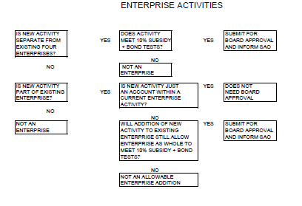

History and Overview of TABOR
In November 1992, Colorado voters approved an amendment to the State Constitution—Article X, Section 20—called the Taxpayer’s Bill of Rights or TABOR. This amendment imposes various limitations on state and local governments, including limitation on the imposition of new or increased taxes, the issuance of multiple fiscal year obligations, and permitted levels of fiscal year spending.

The restrictions imposed by TABOR do not apply to entities or activities characterized as enterprises. An enterprise is defined as a government-owned business which has the authority to issue its own revenue bonds, and which does not receive more than 10% of its annual revenues in “grants” from state and local governments.

During the 1993 legislative session, HB93-1355 was enacted to clarify which auxiliary facilities and activities operated by institutions of higher education within the state might qualify as enterprises. HB93-1355 provides a statutory framework in which auxiliary facilities and activities managed by the Board of Regents may qualify as enterprises so that they comply with the provisions of TABOR. The importance of qualifying as an enterprise lies in the fact that the revenue of the respective auxiliary facility or activity is removed from the revenue and expenditure limits of TABOR.

In September 1993, the Board of Regents passed a resolution designating certain auxiliary facilities and activities as enterprises. These were then reviewed by the State Auditor and presented to the Legislative Audit Committee.

The 1993 list of enterprises included the following:
- Auxiliary Units
  - Bookstore Facilities
  - Housing Facilities (Housing, University Club)
  - Parking Facilities
  - Athletic Facilities (Intercollegiate Athletics)
  - Student Union Facilities (UCSU, Recreation Building, Student Health Facility, Student Buildings)
- Sales and Services of Educational Activities
  - Continuing Education
  - International Education
- Research Facilities
- Other Auxiliary Activities
  - Telecommunications
  - Cogeneration Facilities
  - Artist Series
  - Student Admin Services
  - Student Support Services

In response to the findings and recommendations submitted by the State Auditor to the Legislative Audit Committee in 1994, the University committed to re-examine those auxiliary facilities and activities designated as enterprises.

In December 2002, TABOR designation was once again visited by the Board of Regents. The enterprise designations of the following were reaffirmed:
- Intercollegiate Athletics Facilities and Operations
- Bookstore Facilities and Operations
- Student Recreation Facilities and Operations
- Housing Facilities and Operations
- Student Health and Apothecary Facilities and Operations
- Parking Facilities and Operations
- Student Government Facilities and Operations
- Student Union Facilities and Operations
- Real Estate Leasing Facilities and Operations.

Also at this time, the designation of facilities and activities as Education Services Enterprises was modified and reaffirmed to include University-wide activities and facilities related to:
- Extended Studies Education Facilities and Operations
- International Education Facilities and Operations
- Graduate Medical Education Facilities and Operations.

At this time the designation of facilities and activities as Research Support Services Enterprises was modified and reaffirmed to include University-wide activities and facilities related to:
    - Research Support Operations
    - Research Building Revolving Fund Facilities and Operations.

Additionally, at this time, the designation of facilities and activities as Other Self-Funded Services Enterprises was modified and reaffirmed to include University-wide activities and facilities related to:
    - Dentistry Practice Plans
    - Utility Plant Facilities and Operations
    - Self-Insurance Services
    - Medical Practice Plans
    - Nursing Practice Plans
    - Auditorium and Artist Series Facilities and Operations
    - Pharmacy Practice Plans
    - Telecommunications Facilities and Operations
    - Health Related Fee for Services
    - Conference Services.
The Board of Regents modified one additional TABOR designation during their December 2002 meeting by terminating the inclusion of University East Pavilion Operations from the Other Self-Funded Services Enterprises.

Designations of facilities and activities as enterprises by the Board of Regents remain in effect and continue unless terminated by a resolution on their part.

Passage of Colorado Senate Bill 04-189 in 2004 paved the way for the Regents to approve resolutions on June 2, 2004 and July 8, 2004 designating the entire University as a TABOR enterprise effective July 1, 2004.

enterprise status and current accounting practices
TABOR “enterprises” are exempt from TABOR requirements. To qualify as an enterprise, a higher education institution must be a government-owned business authorized to issue its own revenue bonds and receiving less than 10 percent of its annual revenue in grants from all state and local governments combined. Due in part to years of diminished state funding, the University eventually met both of these criteria; and on July 1, 2004, the University was designated as a TABOR enterprise beginning fiscal year 2005.

The University will maintain its designation as a TABOR enterprise only if it continues to meet both eligibility requirements. Because of the possibility that its TABOR status may one day revert back to non-enterprise status, the University continues to use the same fund structure and accounting conventions that were developed to comply with TABOR reporting requirements.

Some of the TABOR requirements noted in the Handbook are no longer in effect. They do, however, offer insight into the origins of the accounting practices they refer to that are still in use. An excellent guide on TABOR, fund accounting, and state budgetary reporting can be found in the Department of Higher Education Fiscal Guidelines put together by the Controllers of Colorado’s institutions of higher education.

Auxiliary Other Exempt Fund (Fund 26)
The Auxiliary Other Exempt Fund is used to account for revenue generated through departmental activity that is exempt from TABOR reporting for reasons other than being designated a TABOR Enterprise or an Internal Service Center. This primarily includes residuals on federal fixed priced contract sponsored projects (Fund 30) and royalties.

Auxiliary Internal Service Center Fund (Fund 28)
The Auxiliary Internal Service Center Fund is used to account for the activities that have been designated as Internal Service Centers. Two internal service centers, Telecommunication Services and Cogeneration, are designated as TABOR enterprises and are accounted for in Fund 20. Service center activity is exempt from TABOR reporting. Refer to the full discussion on Internal Service Centers found in Chapter 17 of The Accounting Handbook.

Auxiliary Non-Enterprises Fund (Fund 29)
The Auxiliary Non-Enterprises Fund is used to account for revenue generated through departmental activities that cannot be classified in Funds 20, 26 or 28. Fund 29 is the default unrestricted current fund for departmental revenue. These revenues are subject to TABOR reporting. Note: For revenue related to sponsored projects, such as workshop or conference fees, federal regulations must be followed. Per OMB A-110 Subpart C.24, this revenue should be used in one or more of the following ways:
- Added to the budget for the sponsored project and used to further the project objectives,
- Used to finance the non-federal share of the sponsored project,
- Deducted from the total budget for the project to determine the net allowable costs.

Sponsored Projects Fund (Funds 30, 31)
The Grants and Contracts Funds are used to account for sponsored projects negotiated through the Office of Contracts and Grants (OCG) and certain financial aid programs. Fund 30 is used for revenue that is exempt from TABOR reporting based on the type of sponsor i.e., all sponsors other than those required to be accounted for in Fund 31. Fund 31 is used to account for sponsored projects authorized by OCG from agencies of the state of Colorado. Pure state funded projects (i.e. not mixed with federal monies) are set up in Fund 31 in order to track State funds for the contract management process that SB07-228 requires. Fund 31 is used for revenue that is subject to TABOR reporting.

Gift Fund (Fund 34)
The Gift Fund is used to account for all gifts, except those gifts restricted for the Loan Fund or Plant Fund. Gift Fund revenues are exempt from TABOR reporting. Refer to Chapter 15 Gift Accounting in The Accounting Handbook for additional information.

EDUCATIONAL & GENERAL FUNCTIONS (EPC CODES)

Instruction (EPC 1100)
This category should include expenditures for all activities that are part of an institution’s instruction program, with the exception of expenditures for remedial and tutorial instruction which should be categorized as student services. Expenditures for credit and noncredit courses for academic, occupational, and vocational instruction, and for regular, special, and extension sessions should be included in the instruction function. Conferences are not included in this category, as they are classified as public service.
Expenditures for departmental research and public service that are not separately budgeted should be included in this classification. The instruction category excludes expenditures for academic administration when the primary assignment is administration, for example, academic deans. However, expenditures for department chairs, in which instruction is still an important role of the administrator, are included in this category.

EPC 1150 - Instruction Capital Grant
This EPC should be used for all capital equipment purchased for instruction purposes using grant funds.

Research (EPC 1200)
This category should include all expenditures for activities specifically organized to produce research outcomes, whether commissioned by an agency external to the institution or separately budgeted by an organizational unit within the institution. Subject to these conditions, the research category includes expenditures for individual and/or project research as well as those of institutes and research centers. This category does not include all sponsored programs (training grants are an example) nor is it necessarily limited to sponsored research, since internally supported research programs, if separately budgeted, might be included in this category under the circumstances described above. Expenditures for departmental research that are separately budgeted for research are included in this category.

EPC 1250 - Research Capital Grant
This EPC should be used for all capital equipment purchased for research purposes using grant funds.

Public Service (EPC 1300)
This category should include funds expended for activities that are established primarily to provide non-instructional services beneficial to individuals and groups external to the institution. These activities include community service programs (excluding instructional programs) and cooperative extension services. Included in this category are conferences, institutes, general advisory services, reference bureaus, radio and television, consulting and similar non-instructional services particular to sectors of the community.
EPC 1350 - Public service Capital Grant
This EPC should be used for all capital equipment purchased for public service purposes using grant funds.

Academic Support (EPC 1400)
This category should include funds expended primarily to provide support services for the institution’s primary missions—instruction, research, and public service. It includes (1) the retention, preservation, and display of educational materials—for example, libraries, museums, and galleries; (2) the provision of services that directly assist the academic functions of the institution, such as demonstration schools associated with a department, school, or college of education; (3) media, such as audiovisual services and technology such as computing support; (4) academic administration (including academic deans but not department chairmen) and personnel development providing administrative support and management directions to the three primary missions; and (5) separately budgeted support for course and curriculum development. For institutions that currently charge certain expenditures—e.g. computing support—directly to the various operating units of the institution, such expenditures are not reflected in this category.

EPC 1450 - Academic Support Capital Grant
This EPC should be used for all capital equipment purchased for academic support purposes using grant funds.

Student Services (EPC 1500)
This category should include funds expended for offices of admissions and registrar, and also those activities whose primary purpose is to contribute to the student’s emotional and physical well-being and to his intellectual, cultural, and social development outside the context of the formal instruction program. It includes expenditures for student activities, cultural events, student newspapers, intramural athletics, student organizations, intercollegiate athletics (if the program is operated as an integral part of the department of physical education and not as an essentially self-supporting activity), supplemental educational services to provide matriculated students with supplemental instruction outside the normal academic program (remedial instruction is an example), counseling and career guidance (excluding informal academic counseling by the faculty), student aid administration, and student health service (if not operated as an essentially self-supporting activity).

EPC 1550 - Student Services Capital Grant
This EPC should be used for all capital equipment purchased for student services purposes using grant funds.

Institutional Support (EPC 1600)
This category should include expenditures for: (1) central executive-level activities concerned with management and long-range planning of the entire institution, such as the governing board, planning and programming, and legal services; (2) fiscal operations, including the investment office; (3) administrative data processing; (4) space management; (5) employee personnel and records; (6) logistical activities that provide procurement, storerooms, printing, and transportation services to the institution; (7) support services to faculty and staff that are not operated as auxiliary enterprises; and (8) activities concerned with community and alumni relations, including development and fund raising.

Appropriate allocations of institutional support should be made to auxiliary enterprises, hospitals, and any other activities not reported under the Education and General heading of expenditures. CU uses the General Administrative Recharge (GAR) and General Infrastructure Recharge programs (GIR) to allocate a portion of the institutional support and operation and maintenance of plant General Fund costs to all auxiliary and self-funded revenue sources. This is done at the time the auxiliary and self-funded sources are spent, whether from the current funds (2x) or plant funds (78). GAIR is not charged on cash transfers among these funds. The GAR and GIR programs further mandate that auxiliary and self-funded resources not be commingled with General Fund resources, otherwise they would lose their identity and GAIR could not be charged. Hence, CU has created R&R Fund 78 specifically for auxiliary and self-funded operations, and has implemented the restriction prohibiting the transfer of cash from an auxiliary/self-funded (2x) FOPPS to the General Fund.

EPC 1650 - Institutional Support Capital Grant
This EPC should be used for all capital equipment purchased for institutional support purposes using grant funds.

Operation of Plant (EPC 1700)
This category should include all expenditures of current operating funds for the operation and maintenance of physical plant, in all cases net of amounts charged to auxiliary enterprises, hospitals, and independent operations. It does not include expenditures made from the institutional plant fund accounts. It includes all expenditures for operations established to provide services and maintenance related to grounds and facilities. Also included are utilities, fire protection, property insurance and similar items. NACUBO later added safety and security expenditures to this category. These were previously included in the institutional support category.

ABS will use the primary function of the department to assign an EPC to the R&R FOPPS.

EPC 1750 - Operation of Plant Capital Grant
This EPC should be used for all capital equipment purchased for operation and maintenance of plant purposes using grant funds.

Scholarships and Fellowships (EPC 1800)
This category (also referred to as financial aid) should include expenditures for scholarships and fellowships in the form of outright grants to students selected by the institution and financed from current funds, restricted or unrestricted. It also should include trainee stipends, prizes and awards, except for those trainee stipends awarded to individuals who are not enrolled in formal course work, which should be charged to instruction, research, or public service as appropriate. If the institution is given custody of the funds, but is not allowed to select the recipient of the grant, (for example, the federal Basic Educational Opportunity Grants program or ROTC scholarships), the funds should be reported in the agency funds group rather than in the current funds group.

The recipient of an outright grant is not required to perform service to the institution as a consideration for the grant, nor is the recipient expected to repay the amount of the grant to the funding source. When services are required in exchange for financial assistance, as in the College Work-Study Program, the charges should be classified as expenditures of the department or organizational unit to which the service is rendered. Aid provided to students in the form of tuition or fee remissions also should be included in this category. However, remissions of tuition and fees granted due to faculty or staff status, or because of family relationship of students to faculty or staff, should be recorded as staff benefit expenditures in the appropriate functional expenditure category.

In addition to defining financial aid expenses by the EPC assigned to programs and projects, these expenses are also reflected in student aid expense accounts 770000–772499. These accounts must only be used if there are no services required in exchange for the support. If services are required in any form, then that payment should be reflected as a type of salary expense or an employee benefit expense. For financial reporting purposes, all expenses in this range of accounts are classified on the Scholarship and Fellowship line regardless of the EPC on the program or project in which they are booked. All other expenses of the program or project are then classified according to the EPC assigned to that program or project. For example, Athletics programs are assigned EPC 2000, auxiliary enterprise. If any student aid expenses (accounts 770000–772499) are booked in the Athletics programs, those expenses will be classified on the Scholarship and Fellowship line of the financial statements. All other expenses of the Athletic programs (salaries, benefits, operating expense, travel, etc.) will be classified on the Auxiliary Operating Expenditure line.

EPC 1800 must only be assigned to programs and projects where all expenses in that program or project are considered to be financial aid. For example, if there is a training grant whose purpose is to provide financial support to a student in the form of stipend payments, tuition payments, paying for books and perhaps costs of doing research on a thesis or dissertation, then that project should be assigned EPC 1800. All expenses of that project would then be classified as scholarship and fellowships even though the appropriate natural classification of the individual expenses charged to the project was used.

Internal Service Centers (EPC 2100)
An internal service center (ISC) is an entity created primarily to provide goods/services to other institutional departments or organizational units. Incidental sales to the public are permitted. Some ISCs have a substantial amount of sales to the public, such as electricity sales to Public Service Company by Co-generation and long distance service sales to students by Telecommunication Services. In these situations, looking at the customer base and revenues streams for each does not provide a clear-cut decision regarding whether to classify the entity as an ISC or an auxiliary enterprise. Therefore, professional judgment must be used to determine the primary reason the entity was created. In each of these two cases, the entity was created primarily to provide services to institutional departments and organizational units. Therefore, management’s intent was to create an ISC, which is how these two entities are classified.

The Audit Guide SOP page 53 says that interdepartmental transactions between service departments and storerooms and other institutional departments or offices should not be reported as revenues of the service departments, but rather as reduction of expenditures of such departments, since these transactions are essentially interdepartmental transfers of costs. The billed price of services and materials obtained from service departments and central stores by offices and departments of the institution should be accounted for as expenditures of those offices and departments, just as if they had been obtained from sources outside the institution. Any difference between costs and billed prices as recorded in the service department accounts, whether debit or credit, should be reported under the Institutional Support expenditures classification.

All ISCs are accounted for in the Auxiliary Internal Service Center Fund (Fund 28), except for Cogeneration and Telecommunication Services which are in Fund 20 due to their TABOR Enterprise designation. Therefore, all Fund 28 FOPPS should have an EPC of 2100, and no FOPPS outside of Fund 28 (with the exceptions of Cogeneration and Telecommunication Services) should have an EPC of 2100.

While the SOP requires that ISC sales not be reported as revenue, but rather as a reduction of expense, ISC managers need to be able to track their revenue separate from their expenses. Therefore, revenue accounts 380000–389999 have been established specifically for ISC sales to other departments or offices. Sales to private individuals such as students, faculty, staff, businesses, or Agency Fund FOPPS are true revenue to the institution, and must be recorded as miscellaneous revenue in accounts 325000–334999. It would be inappropriate to use the auxiliary revenue accounts for these sales, even the telecommunication sales to students, because these entities are not classified as auxiliary enterprises. The purchasing FOPPS will record expense in an expense account as if the purchase had been made from an outside vendor.

In order to meet the reporting requirement, the University’s financial reports combine the Interdepartmental (IN) revenue and expense account amounts of ISCs on the Institutional Support expenditures category.

Please refer to Chapter 17 of The Accounting Handbook, Internal Service Centers, for complete information on managing ISCs, including federal requirements.

Non-ISC Sales between Departments
To further understand the concept of non-ISC sales between departments, this section will look at non-ISC sales in the context of all internal sales.
Occasionally one department will provide services to another department for a fee, or will sell unneeded supplies or equipment to the other department, even though neither department is designated as an ISC. These sales can be just occasional, casual business transactions between departments, or they can be part of one department’s role and mission, as is the case with Facilities Management. Facilities Management is designated as an Operation and Maintenance of Plant department (EPC1700) and not an ISC (EPC2100). Their role and mission is to maintain the physical plant of the campus. Since Facilities Management has the staff and expertise needed for their role and mission, they also offer to do work on a fee basis at the request of departments. Just like the activities of an ISC, these interdepartmental transactions must be recorded in a way so as to not inflate the revenue and expense of the institution through internal business activity.

Interdepartmental sales and purchases of goods and services (payment between FOPPS for goods/services provided) occur in one of three contexts.

Internal Service Center Sales (IN)
The selling department is a formal Internal Service Center (ISC) in a Fund 28 FOPPS as discussed above.

Auxiliary Enterprise Interdepartmental Sales
Auxiliary Enterprises are established to sell goods and services to outside parties, but will have miscellaneous sales to other University departments as discussed above.

Other Interdepartmental Revenue (ID)
The selling department is another type of University department in either Fund 10, 20, 26, or 29 (i.e., not an Internal Service Center or an Auxiliary Enterprise). Departments in these FOPPS were set up for purposes other than to provide goods/services to other departments, but will occasionally do so. In other words, this category refers to those miscellaneous transactions providing goods or services from one department to another, e.g., sale of manufactured chemicals, sale of a professor’s time to conduct a study, facility repair services, housing services, police services, etc. Note: FOPPS in Funds 28, 30, 31, 34, 50, 71, 72, 73, 74 and 78 cannot be selling departments for other interdepartmental sales (ID). The selling FOPPS will record revenue for other interdepartmental revenue (ID) in accounts 390000–399999 (Other ID Revenue).

The purchasing FOPPS must use an expense account from the designated list of Other Interdepartmental Expense accounts (Other ID Expense accounts). Departments cannot use just any expense account from the full chart of accounts. The ID revenue and expense accounts set up as of this original printing are listed in the Quick Reference Card section immediately following the Revenue section and preceding the Asset section. A complete and current list of ID revenue and expense accounts is on the Chart of Accounts available on the System Controller’s website.

Each internal sale and purchase determined to be ID revenue must use the designated ID accounts in order to identify both sides of these transactions and thus report them on the University’s financial statements and in the state’s accounting system in a manner that does not inflate total revenue and expense resulting from internal sales. The department recording the transaction (usually the selling department) is responsible for ensuring the designated ID accounts are used on both the selling and purchasing FOPPS.

TRANSFERS
Transfers are the movement of cash and fund balance from one fund to another. No goods or services are provided in exchange for the cash transfer. Remember that the Audit Guide ¶2.03 defines a fund as an accounting entity with a self-balancing set of accounts for recording assets, liabilities, fund balance, and changes in the fund balance. A portion of the assets is cash, and there are occasions when management wants to move cash and fund balance from one fund to another fund without involving a sale of goods or services between the two FOPPS. Examples include funding a new program for start-up costs, funding a capital construction project, or funding a renewal and replacement reserve. Transfers are further classified as mandatory or voluntary (or non-mandatory).

Mandatory Transfers
Mandatory transfers include transfers from the current funds group to other fund groups arising out of (1) binding legal agreements related to the financing of educational plant, such as amounts for debt retirement, interest, and required provisions for renewals and replacements of plant not financed from other sources and (2) grant agreements with agencies of the federal government, donors, and other organizations to match gifts and grants to loan and other funds. Mandatory transfers may be required to be made from either unrestricted or restricted current funds.
- Mandatory transfer use accounts 990000–994999.

Voluntary Transfers
Voluntary transfers include those transfers from the current funds group to other fund groups made at the discretion of the governing board (management) to serve a variety of objectives, such as additions to loan funds, additions to quasi-endowment funds, general or specific plant additions, voluntary renewals and replacements of plant, and prepayments on debt principal. Voluntary transfers also may involve the re-transfer of resources back to the current funds. Cash and fund balance transfers should not be done by moving revenue or expense.
- Voluntary transfers use accounts 995000–999999.

Restrictions on Transfers
Cash transfers are not permitted between all fund combinations. For example, the transfer of cash from the restricted current fund to the unrestricted current fund changes the nature and financial reporting of that cash. The transfer of cash between an agency fund and any other fund is never allowed, since agency funds represent an outside, private interest, and the processing of gifts to the University is guided by various administrative policies.
The following table shows the fund combinations where it is allowable to make cash transfers. To use this table, identify the fund of the FOPPS that is going to give up the cash (the From fund) on the left hand side of the table. Next, identify the FOPPS that is going to receive the cash (the To fund) along the top row of the table. If the intersection of these two funds says Yes, then a cash transfer is allowable between the two FOPPS. If the intersection is blank, then a cash transfer is not permitted between the two FOPPS.
Cash Transfer Table
TO FUND

 |  | 10 | 11 | 20 | 26 | 28 | 29 | 30 | 31 | 34 | 50 | 71 | 72 | 73 | 74 | 78 | 80 | 99
 | 10 | BJE |  | yes | yes | yes | yes |  |  |  |  | yes | yes | yes
 | 11
 | 20¹ |  |  | yes | yes | yes | yes |  |  |  |  | yes |  | yes |  | yes
F | 26 |  |  | yes | yes | yes | yes |  |  |  |  | yes |  | yes |  | yes
R | 28 |  |  |  |  |  |  |  |  |  |  |  |  |  |  | yes
O | 29 |  |  | yes | yes | yes | yes |  |  |  |  | yes |  | yes |  | yes
M | 30
 | 31
F | 34² |  |  |  |  |  |  |  |  | yes |  | yes
U | 50
N | 71 | yes |  | yes | yes |  | yes |  |  | yes |  | yes | yes | yes |  | yes
D | 72 | yes |  |  |  |  |  |  |  |  |  | yes | yes | yes
 | 73 | yes |  | yes | yes |  | yes |  |  |  |  | yes | yes | yes |  | yes
 | 74
 | 78 |  |  | yes | yes | yes | yes |  |  |  |  | yes |  | yes |  | yes
 | 80 |  |  |  |  |  |  |  |  |  |  |  |  |  |  |  | yes
 | 99

¹Fund 20 Note: Athletics, Bookstore, Housing, Parking, Real Estate Leasing Facilities & Operations, RBRF, Recreation Center, Research Buildings, Research Park, Research Support Operations, Student Organizations Finance Office/UCSU, Telecommunications, UMC, and Wardenburg are not allowed to make cash transfers to the General Fund. In addition, for those FOPPS with Auxiliary Enterprise Attributes of PAA, PAB, PAD, PAH, PAM, PAP, PAR, PAS, PAU, PRL, PRR, POO, POT, and POY, Revised Statute 23-5-103(3) prohibits auxiliary facilities whose net income is pledged to revenue bonds from making cash transfers to any entity whose net income is NOT cross-pledged to revenue bonds.
² Fund 34 Note: The primary Gift Purpose Codes must match on fund 34 transfers or it must receive approval from the ABS Gift Fund Accountant.

ATTACHMENTS
Exhibits that provide examples of the Audit Guide financial reports as well as the GASB 34/35 financial reports can be found on the pages that follow.

Attachment A—Audit Guide Statements
    - Exhibit 1 Balance Sheet
    - Exhibit 2 Statement of Changes in Fund Balances
    - Exhibit 3 Statement of Current Funds Revenues, Expenditures
and Other Changes

Attachment B—GASB 34/35 Statements
    - Exhibit 1 Statement of Net Assets
    - Exhibit 2 Statement of Revenue, Expenses and Changes in Net Assets
    - Exhibit 3 Statement of Cash Flows

Attachment C—Fiscal Year 2001 Audit Guide Statements for CU
    - Exhibit 1 Balance Sheet
    - Exhibit 2 Statement of Changes in Fund Balances
    - Exhibit 3 Statement of Current Funds Revenues, Expenditures
and Other Changes

Attachment A – Sample Audit Guide Statements
Exhibit 1
(Back to text page 3, 8)

SAMPLE EDUCATIONAL INSTITUTION
Balance Sheet
June 30, 201x
with comparative figures at June 30, 201x

Assets | Current year | Prior  year | Liabilities and Fund Balances | Current year | Prior  year
Current funds: |  |  | Current funds:
Unrestricted: |  |  | Unrestricted:
Cash | $ 210,000 | $ 110,000 | Accounts payable | $ 125,000 | $ 100,000
Investments | 450,000 | 360,000 | Accrued liabilities | 20,000 | 15,000
Accounts receivable, less allow-  ance of $18,000 both years | 228,000 | 175,000 | Student’s deposits | 30,000 | 35,000
Accounts receivable, less allow-  ance of $18,000 both years | 228,000 | 175,000 | Due to other funds | 158,000 | 120,000
Inventories at lower of cost (first-in  first-out basis) or market | 90,000 | 80,000 | Deferred credits | 30,000 | 20,000
 | 90,000 | 80,000 | Fund balance | 643,000 | 455,000
Prepaid expenses & deferred charges | 28,000 | 20,000
Total unrestricted | 1,006,000 | 745,000 | Total unrestricted | 1,006,000 | 745,000
Restricted: |  |  | Restricted:
Cash | 145,000 | 101,000 | Accounts payable | 14,000 | 5,000
Investments | 175,000 | 165,000 | Fund balances | 446,000 | 421,000
Accounts receivable, less allow-  ance of $8,000 both years | 68,000 | 160,000
Unbilled charges | 72,000 | - - - - -
Total restricted | 460,000 | 426,000 | Total restricted | 460,000 | 426,000
Total current funds | 1,466,000 | 1,171,000 | Total current funds | 1,466,000 | 1,171,000
Loan funds: | 30,000 | 20,000 | Loan funds:
Cash | 100,000 | 100,000 | Fund balances:
Investments |  |  | U.S. government grants refundable | 50,000 | 33,000
Loans to students, faculty, & staff,  less allowance of $10,000 current  year and $9,000 prior year | 550,000 | 382,000 | University funds
 | 550,000 | 382,000 | Restricted | 483,000 | 369,000
 | 550,000 | 382,000 | Unrestricted | 150,000 | 100,000
Due from unrestricted funds | 3,000 | - - - - -
Total loan funds | 683,000 | 502,000 | Total loan funds | 683,000 | 502,000
Endowment and similar funds: |  |  | Endowment and similar funds:
Cash | 100,000 | 101,000 | Fund balances:
Investments | 13,900,000 | 11,800,000 | Endowment | 7,800,000 | 6,740,000
 |  |  | Term endowment | 3,840,000 | 3,420,000
 |  |  | Quasi-endowment unrestricted | 1,000,000 | 800,000
 |  |  | Quasi-endowment restricted | 1,360,000 | 941,000
Total endowment and similar funds | 14,000,000 | 11,901,000 | Total endowment and similar funds | 14,000,000 | 11,901,000

continued
SAMPLE EDUCATIONAL INSTITUTION
Balance Sheet, continued

Assets | Current year | Prior  year | Liabilities and Fund Balances | Current year | Prior  year
Annuity and life income funds: |  |  | Annuity and life income funds:
Annuity funds: |  |  | Annuity funds:
Cash | 55,000 | 45,000 | Annuities payable | 2,150,000 | 2,300,000
Investments | 3,260,000 | 3,010,000 | Fund balances | 1,165,000 | 755,000
Total annuity funds | 3,315,000 | 3,055,000 | Total annuity funds | 3,315,000 | 3,055,000
Life income funds: |  |  | Life income funds:
Cash | 15,000 | 15,000 | Income payable | 5,000 | 5,000
Investments | 2,045,000 | 1,740,000 | Fund balances | 2,055,000 | 1,750000
Total life income funds | 2,060,000 | 1,755,000 | Total life income funds | 2,060,000 | 1,755,000
Total annuity and life income funds | 5,375,000 | 4,810,000 | Total annuity and life income funds | 5,375,000 | 4,810,000
Plant funds: |  |  | Plant funds:
Unexpended: |  |  | Unexpended:
Cash | 275,000 | 410,000 | Accounts payable | 10,000 | -----
Investments | 1,285,000 | 1,590,000 | Notes payable | 100,000 | -----
Due from unrestricted current funds | 150,000 | 120,000 | Bonds payable | 400,000 | -----
 |  |  | Fund balances:
 |  |  | Restricted | 1,000,000 | 1,860,000
 |  |  | Unrestricted | 200,000 | 260,000
Total unexpended | 1,710,000 | 2,120,000 | Total unexpended | 1,710,000 | 2,120,000
Renewals and replacements: |  |  | Renewals and replacements:
Cash | 5,000 | 4,000 | Fund balances:
Investments | 150,000 | 286,000 | Restricted | 25,000 | 180,000
Deposits with trustees | 100,000 | 90,000 | Unrestricted | 235,000 | 200,000
Due from unrestricted current funds | 5,000 | - - - - -
Total renewals and replacements | 260,000 | 380,000 | Total renewals and replacements | 260,000 | 380,000
Retirement of indebtedness: |  |  | Retirement of indebtedness:
Cash | 50,000 | 40,000 | Fund balances:
Deposits with trustees | 250,000 | 253,000 | Restricted | 185,000 | 125,000
 |  |  | Unrestricted | 115,000 | 168,000
Total retirement of indebtedness | 300,000 | 293,000 | Total retirement of indebtedness | 300,000 | 293,000
Investment in plant:: |  |  | Investment in plant::
Land | 500,000 | 500,000 | Notes payable | 790,000 | 810,000
Land improvements | 1,000,000 | 1,110,000 | Bonds payable | 2,200,000 | 2,400,000
Buildings | 25,000,000 | 24,060,000 | Mortgages payable | 400,000 | 200,000
Equipment | 15,000,000 | 14,200,000 | Net investment in plant | 38,210,000 | 36,540,000
Library books | 100,000 | 80,000
Total Investment in plant | 41,600,000 | 39,950,000 | Total Investment in plant | 41,600,000 | 39,950,000
Total plant funds | 43,870,000 | 42,743,000 | Total plant funds | 43,870,000 | 42,743,000

continued
SAMPLE EDUCATIONAL INSTITUTION
Balance Sheet, continued

Assets | Current year | Prior  year | Liabilities and Fund Balances | Current year | Prior  year
Agency funds: |  |  | Agency funds:
Cash | 50,000 | 70,000 | Deposits held in custody for others | 110,000 | 90,000
Investments | 60,000 | 20,000
Total agency funds | 110,000 | 90,000 | Total annuity funds | 110,000 | 90,000

Attachment A - Exhibit 2

SAMPLE EDUCATIONAL INSTITUTION
Statement of Changes in Fund Balances
Year Ended June 30, 201x

 | Current Funds |  |  |  |  | Plant Funds
 | Unre-  stricted | Re-  stricted | Loan Funds | Endow-  ment &  Similar  Funds | Annuity  & Life  Income  Funds | Unex-  pended | Renewal  and  Replace-  ments | Retire-  ment of  Indebt-  edness | Invest-ment  in  Plant
Revenues and
other additions:
Unrestricted current fund  revenues | $ 7,540,000
Expired term endowment -  restricted |  |  |  |  |  | 50,000
State appropriations -  restricted |  |  |  |  |  | 50,000
Federal grants & contracts  restricted |  | 500,000
Private gifts, grants, and  contracts - restricted |  | 370,000 | 100,000 | 1,500,000 | 800,000 | 115,000 |  | 65,000 | 15,000
Investment income -  restricted |  | 224,000 | 12,000 | 10,000 |  | 5,000 | 5,000 | 5,000
Realized gains on  investments - unrestricted |  |  |  | 109,000
Realized gains on invest-  ments -restricted |  |  | 4,000 | 50,000 |  | 10,000 | 5,000 | 5,000
Interest on loans receivable |  |  | 7,000
U.S. government advances |  |  | 18,000
Expended for plant facil -  ities (including $100,000  charged to current fund  expenditures) |  |  |  |  |  |  |  |  | 1,550,000
Retirement of indebtedness |  |  |  |  |  |  |  |  | 220,000
Accrued interest on sale of  bonds |  |  |  |  |  |  |  | 3,000
Matured annuity and life  income restricted to  endowment |  |  |  | 10,000
Total revenues and  other additions | 7,540,000 | 1,094,000 | 141,000 | 1,679,000 | 800,000 | 230,000 | 10,000 | 78,000 | 1,785,000

continued

SAMPLE EDUCATIONAL INSTITUTION
Statement of Changes in Fund Balances - continued
Year Ended June 30, 201x

 | Current Funds |  |  |  |  | Plant Funds
 | Unre-  stricted | Re-  stricted | Loan Funds | Endow-  ment &  Similar  Funds | Annuity  & Life  Income  Funds | Unex-  pended | Renewal  and  Replace-  ments | Retire-  ment of  Indebt-  edness | Invest-ment  in  Plant
Expenditures and other
deductions:
Educational and general  expenditures | 4,400,000 | 1,014,000
Auxiliary enterprises
expenditures
Indirect costs recovered |  | 35,000
Refunded to grantors |  | 20,000 | 10,000
Loan cancellations and  write-offs |  |  | 1,000
Administrative and  collection costs |  |  | 1,000 |  |  |  |  | 1,000
Adjustment of actuarial  liability for annuities  payable |  |  |  |  | 75,000
Expended for plant facilities  (including non-capitalized  expenditures of $75,000) |  |  |  |  |  | 1,200,000 | 300,000
Retirement of indebtedness |  |  |  |  |  |  |  | 220,000
Interest on indebtedness |  |  |  |  |  |  |  | 190,000
Disposal of plant facilities |  |  |  |  |  |  |  |  | 115,000
Expired term endowments  ($40,000 unrestricted,  ($75,000 restricted to  plant) |  |  |  | 90,000
Matured annuity and life  income funds restricted  to endowment |  |  |  |  | 10,000
Total expenditures and  other deductions | 6,230,000 | 1,069,000 | 12,000 | 90,000 | 85,000 | 1,200,000 | 300,000 | 411,000 | 115,000

continued

SAMPLE EDUCATIONAL INSTITUTION
Statement of Changes in Fund Balances - continued
Year Ended June 30, 201x

 | Current Funds |  |  |  |  | Plant Funds
 | Unre-  stricted | Re-  stricted | Loan Funds | Endow-  ment &  Similar  Funds | Annuity  & Life  Income  Funds | Unex-  pended | Renewal  and  Replace-  ments | Retire-  ment of  Indebt-  edness | Invest-ment  in  Plant
Transfers among funds -
additions/(deductions):
Mandatory: |  |  |  |  |  |  |  | 340,000
Principal and interest | (340,000)
Renewals & replacements | (170,000) |  |  |  |  |  | 170,000
Loan fund matching grant | (2,000) |  | 2,000
Unrestricted gifts allocated | (650,000) |  | 50,000 | 550,000 |  | 50,000
Portion of unrestricted  quasi-endowment funds  investment gains  appropriated | 40,000 |  |  | (40,000)
Total Transfers | (1,122,000) |  | 52,000 | 510,000 |  | 50,000 | 170,000 | 340,000
Net increase/(decrease)  for the year | 188,000 | 25,000 | 14,000 | 2,099,000 | 715,000 | (920,000) | (120,000) | 7,000 | 1,670,000
Fund balance at beginning  of the year | 455,000 | 421,000 | 502,000 | 11,901,000 | 2,505,000 | 2,120,000 | 380,000 | 293,000 | 36,540,000
Fund balance at end  of the year | $643,000 | $446,000 | $683,000 | $14,000,000 | $3,220,000 | $1,200,000 | $260,000 | $300,000 | $38,210,000

Attachment A - Exhibit 3

SAMPLE EDUCATIONAL INSTITUTION
Statement of Current Funds Revenues, Expenditures, and Other Changes
Year Ended June 30, 201x

 |  | Current Year
Revenues: |  | Unrestricted | Restricted | Total |  | Prior Year Total
Tuition and fees |  | $2,600,000 |  | 2,600,000 |  | 2,300,000
Federal appropriations |  | 500,000 |  | 500,000 |  | 500,000
State appropriations |  | 700,000 |  | 700,000 |  | 700,000
Local appropriations |  | 100,000 |  | 100,000 |  | 100,000
Federal grants and contracts |  | 20,000 | 375,000 | 395,000 |  | 350,000
State grants and contracts |  | 10,000 | 25,000 | 35,000 |  | 200,000
Local states and contracts |  | 5,000 | 25,000 | 30,000 |  | 45,000
Private gifts, grants and contracts |  | 850,000 | 380,000 | 1,230,000 |  | 1,190,000
Endowment income |  | 325,000 | 209,000 | 534,000 |  | 500,000
Sales and services of educational depts |  | 190,000 |  | 190,000 |  | 195,000
Sales and services of auxiliary enterprises |  | 2,200,000 |  | 2,200,000 |  | 2,100,000
Expired term endowment |  | 40,000 |  | 40,000
Other sources (if any)
Total current revenues |  | 7,540,000 | 1,014,000 | 8,554,000 |  | 8,180,000
Expenditures and mandatory transfers:
Educational and general: |  | 2,960,000 | 489,000 | 3,449,000 |  | 3,300,000
Instruction |  | 100,000 | 400,000 | 500,000 |  | 650,000
Research |  | 130,000 | 25,000 | 155,000 |  | 175,000
Public service |  | 250,000 |  | 250,000 |  | 225,000
Academic support |  | 200,000 |  | 200,000 |  | 195,000
Student services |  | 450,000 |  | 450,000 |  | 445,000
Institutional support
Operation and maintenance of plant |  | 220,000 |  | 220,000 |  | 200,000
Scholarships and fellowships |  | 90,000 | 100,000 | 190,000 |  | 180,000
Educational and general expenditures |  | 4,400,000 | 1,014,000 | 5,414,000 |  | 5,370,000
Mandatory transfers for
Principal and interest |  | 90,000 |  | 90,000 |  | 50,000
Renewals and replacements |  | 100,000 |  | 100,000 |  | 80,000
Loan fund matching grant |  | 2,000 |  | 2,000
Total educational and general |  | 4,592,000 | 1,014,000 | 5,606,000 |  | 5,500,000
Auxiliary enterprises
Expenditures |  | 1,830,000 |  | 1,830,000 |  | 1,730,000
Mandatory transfers for
Principal and interest |  | 250,000 |  | 250,000 |  | 250,000
Renewals and replacements |  | 70,000 |  | 70,000 |  | 70,000
Total auxiliary enterprises |  | 2,150,000 |  | 2,150,000 |  | 2,050,000
Total expenditures and mandatory transfers |  | 6,742,000 | 1,014,000 | 7,756,000 |  | 7,550,000
Other transfers and additions/(deductions):
Excess of restricted receipts over transfers to  revenues |  |  | 45,000 | 45,000 |  | 40,000
Refunded to grantors |  |  | (20,000) | (20,000)
Unrestricted gifts allocated to other funds |  | (650,000) |  | (650,000) |  | (510,000)
Portion of quasi-endowment gains appropriated |  | 40,000 |  | 40,000
Net increase in fund balances |  | 188,000 | 25,000 | 213,000 |  | 160,000

Attachment B – Statement of Net Assets

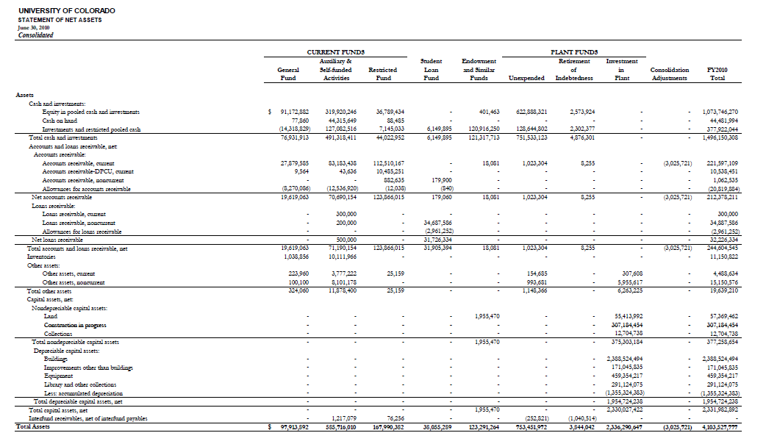

Attachment B – Statement of Net Assets - Continued

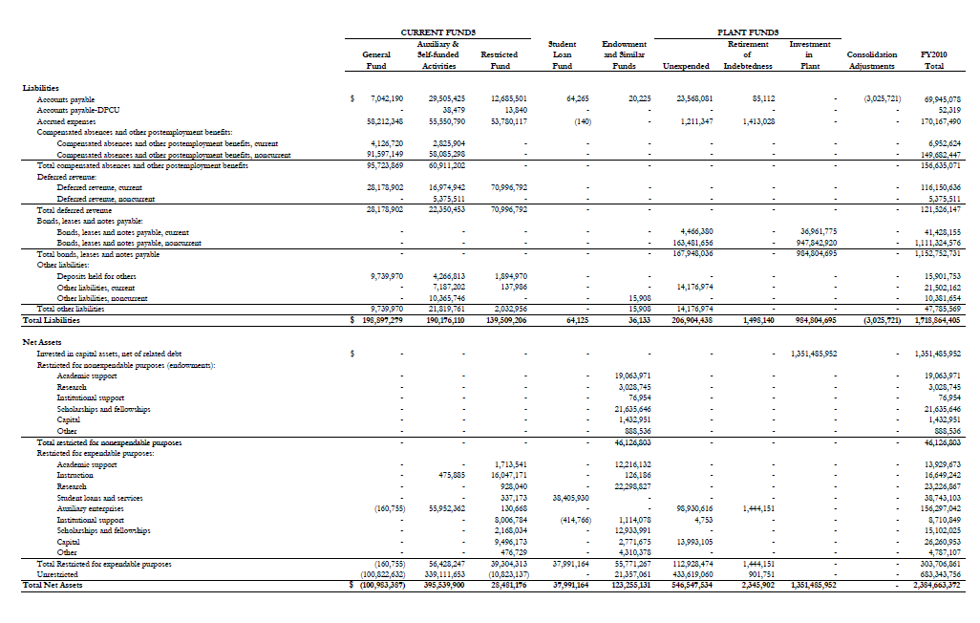

Attachment B – Statement of Revenues, Expenses, and Changes in Net Assets

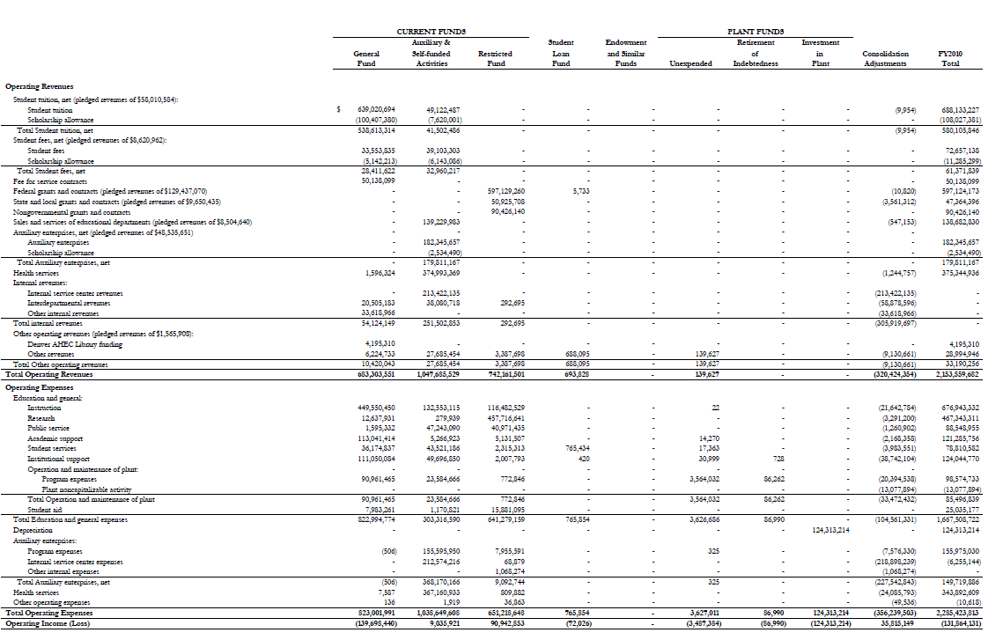

Attachment B – Statement of Revenues, Expenses, and Changes in Net Assets - Continued
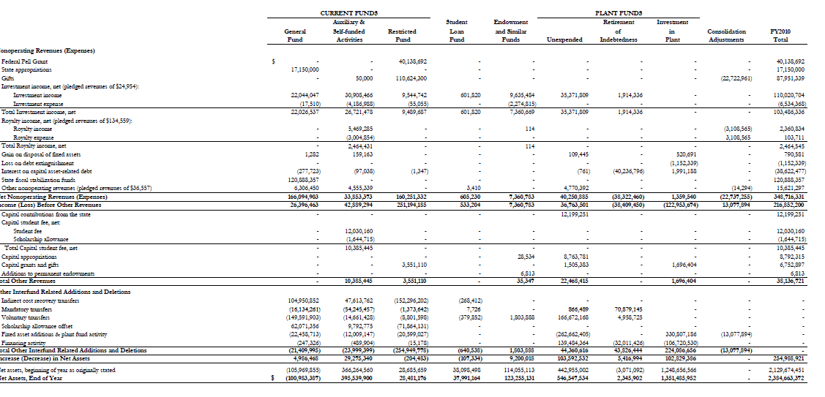

Attachment B – Statement of Cash Flows

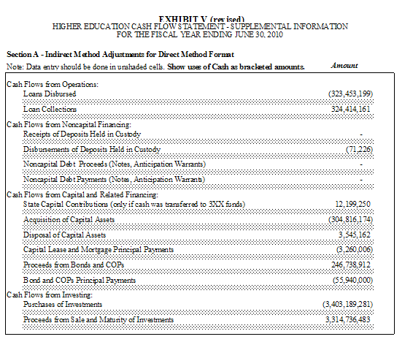

Industry Audit Guide, Audits of Colleges and Universities with Conforming Changes as of May 1, 1992, AICPA, page 5.
Industry Audit Guide, Audits of Colleges and Universities with Conforming Changes as of May 1, 1992, AICPA, page 5.
Industry Audit Guide, Audits of Colleges and Universities with Conforming Changes as of May 1, 1992, AICPA, page 5.
Financial Accounting and Reporting by Colleges and Universities, Statement of Position 74-8, August 31, 1974, AICPA, page 51.
Industry Audit Guide, Audits of Colleges and Universities with Conforming Changes as of May 1, 1992, AICPA, page 5.
Industry Audit Guide, Audits of Colleges and Universities with Conforming Changes as of May 1, 1992, AICPA, page 37.
Industry Audit Guide, Audits of Colleges and Universities with Conforming Changes as of May 1, 1992, AICPA, page 31
Industry Audit Guide, Audits of Colleges and Universities with Conforming Changes as of May 1, 1992, AICPA, page 21.
Financial Accounting and Reporting by Colleges and Universities, Statement of Position 74-8, August 31, 1974, AICPA, page 51.
Financial Accounting and Reporting by Colleges and Universities, Statement of Position 74-8, August 31, 1974, AICPA, page 53.
Industry Audit Guide, Audits of Colleges and Universities with Conforming Changes as of May 1, 1992, AICPA, page 5.

