CHAPTER 5: PeopleSoft Finance System Values
TABLE OF CONTENTS

I. CHAPTER PURPOSE 1
II. CHARTFIELDS 1
A. Business Unit ChartField: Default 1
B. FOPP 1
C. Fund ChartField: 2 Digits, Required, Input By User 2
1. Fund 2
2. Fund Group 2
D. Organization ChartField: 5 Digits, Required, Input by User 3
E. Program/Project ChartField: 5 Digits, Required, Input by User 4
1. Program 4
2. Project 4
F. Sub-Class ChartField: Not Required 5
G. Account ChartField: 6 Digits, Required, Input By User 5
1. Asset Account Range: 000000-099999 5
2. Liability Account Range: 100000-199899 5
3. Fund Balance/Net Assets Account Range: 199900-199999 5
4. Revenue Account Range: 200000-399999 5
5. Expenditure Account Range: 400000-989999 6
6. Transfer Account Range: 990000-999999 6
H. Budget Year: Default 6
I. Statistics Code: Not Required 6
J. Currency Code: Default 6
K. Sample FOPPS 7
L. FOPPS Responsibility: 7
M. SpeedType: 8 Digits 7

CHAPTER PURPOSE
The purpose of this chapter of The Accounting Handbook is to provide information about the coding structure of the University’s Chart of Accounts in the PeopleSoft Finance System.

CHARTFIELDS

The University’s Chart of Accounts in the PeopleSoft Finance System is made up of 10 blocks of information called ChartFields. ChartFields can be joined together in various combinations to tell the PeopleSoft Finance System where to record a transaction. The complete ChartField string looks like this:
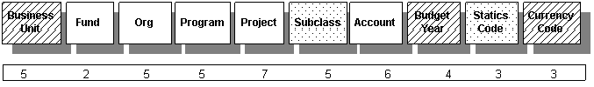
Change “Statics Code” to “Statistics Code.”
ChartFields with diagonal lines through them will default in the system so you do not have to enter them every time you do a transaction. Shaded ChartFields are optional and will be discussed below. Solid ChartFields are determined and entered by the user (you).

Business Unit ChartField: Default
The Business Unit accommodates different operating rules, reporting rules, and regulations. UCOLO is the business unit used by all campuses of the University of Colorado for virtually all transactions. It is a mandatory field and it defaults appropriately so you do not need to assign it manually when you do online data entry.

FOPP
The FOPP stands for Fund, Organization, and Program or Project. It is the central element of the PeopleSoft Finance System coding. The Fund/Org/Program or Fund/Org/Project combination describes a functional unit that has been established for a specific purpose within the University. Each FOPP has a designated individual who is responsible for overseeing the general financial health and specific transaction activity of the FOPP. FOPPs are used to maintain the financial records of a unit or activity within the University.
The FOPP is either a 12-digit number (2-digit fund code, 5-digit organization code, and 5-digit program code) or – for project FOPPs – a 14-digit number (2-digit fund code, 5-digit organization code, and 7-digit project code, which includes sponsored projects and construction projects).

The FOPP, then, describes the type of money (Fund) being received or spent by a specific Org on a type of activity. For Program FOPPs, this pertains to a given fiscal year. Project FOPPs are tracked across their project years.

Fund ChartField: 2 Digits, Required, Input By User
The Fund ChartField contains values that broadly classify types of funding. This ChartField identifies the type of money being received or the type of money being spent. Using the Fund ChartField within a FOPP is mandatory.

Fund
A Fund is a self-balancing set of records that includes assets, liabilities, revenue, expense, and fund balance. The fund identifies the source of the money being received and spent.

Fund Group
A Fund Group is a collection of funds that have a common purpose. The Fund Group is used to identify a general classification of resources.

00 | Memo Bank Fund
10 | Unrestricted General Operating Fund
11 | Unrestricted General Operating Fund – Indirect Cost Recovery
20 | Auxiliary – TABOR Enterprises Fund
26 | Auxiliary Non-Enterprises Fund
28 | Internal Service Operations Fund
29 | Other Self-Funded Operations
30 | Sponsored Projects – Federal
31 | Sponsored Projects – State and Local Governments
34 | Restricted Gifts
50 | Loan Funds
60 | Endowment Funds
71 | Unexpended Plant (Capital Construction)
72 | Renewal & Replacement
73 | Debt Service
74 | Investment in Plant
75 | Unexpended Plant – Non-Exempt
76 | Renewal & Replacement – Non-Exempt
77 | Debt Service – Non-Exempt
78 | Renewal & Replacement – Auxiliary Exempt
79 | Renewal & Replacement – Auxiliary Non-Exempt
80 | Agency Funds
99 | Financial Statement Presentation Fund

Organization ChartField: 5 Digits, Required, Input by User
The Organization ChartField identifies the entity (campus, school, department, etc.) receiving or spending the funds. The first digit of the Organization ChartField represents the respective University of Colorado campus as follows:
1 | Boulder
2 | Health Sciences Center* (old)
3 | Denver* (old)
4 | Colorado Springs
5 | System Administration
6 | UCD/AMC* (new)

* The identifier for the consolidated Denver and Anschutz (formerly Health Sciences Center) campus is “6” and “UCD” includes both campuses. Organization numbers created for the Denver campus and Health Sciences Center prior to the consolidation will not change.

Use of the Organization ChartField is mandatory in the Finance System.

The Finance System permits the use of a hierarchy of different levels when working with organizations. Some departments may choose to run all of their operations from one organization, while other departments may choose to break down their overall operations into smaller segments that reflect responsibility units within the larger organization.

Use the Organization Tree Browser to review specific organization information.

Program/Project ChartField: 5 Digits, Required, Input by User
Each activity will either be a Program or Project, but never both, with one exception: Both program and project may be used to reflect matching/cost sharing. Using either the Program or Project/Grant ChartField within a FOPPS is mandatory.

Program
The Program ChartField identifies distinct University activities for one or more fund(s) and organization(s). Programs are based on the University’s fiscal year. Thus, a program is used to track the financial impact during a budget (fiscal) year of a distinct activity within an organization. The Program ChartField is used in the following funds:
10, 11 | General
20, 26, 28, 29 | Auxiliary
34 | Gift
72, 78 | Renewal & Replacement
73 | Retirement of Indebtedness
74 | Invested in Plant Fund
80 | Agency Fund
99 | Presentation Fund

Project
Similar to the Program ChartField, the Project ChartField identifies a specific sponsored activity within the University. However, a project is not fiscal year based. Rather, a project is based upon the period of the project. The Project ChartField is used in the following funds:
50 | Loan
30, 31 | Grant/Contract Restricted
71 | Capital Construction

Sub-Class ChartField: Not Required
The Sub-Class ChartField is used to capture department-defined needs. Its use is optional. The FOPPS below shows the use of a Sub-Class. The Sub-Class ChartField can be alpha-numeric and consists of 5 characters.

10 10025 10236 PH303
SubClass = Photography

Program = Publications

Org = University Communications

Fund = General

Account ChartField: 6 Digits, Required, Input By User
The Account ChartField describes the activity that is being done by identifying the natural classification of the transaction: Asset, Liability, Fund Balance/Net Assets, Revenue, Expense, or Transfer. All financial transactions must be designated by one of these categories. The use of the Account ChartField is mandatory. A list that describes frequently used accounts follows:

Asset Account Range: 000000-099999
An Asset is tangible or intangible personal and real property such as cash, investments, inventory, accounts receivable, loans receivable, prepaid expenses, equipment, building, etc. Assets are found on the balance sheet.

Liability Account Range: 100000-199899
A Liability is an amount owed to an external entity. Liabilities are found on the balance sheet.

Fund Balance/Net Assets Account Range: 199900-199999
Fund Balance/Net Assets equals Assets minus Liabilities or A - L = FB.
Fund Balance/Net Assets is found on the balance sheet.

Revenue Account Range: 200000-399999
Revenue results from the sale of goods or services. It is measured by the charge made to customers for the goods or services furnished to them. CU-Boulder records revenue when it is earned—that is when the goods or services have been furnished—regardless of when the payment is actually received from the customer.

Expenditure Account Range: 400000-989999
Expenditure is an accounting entry that recognizes the consumption of assets. Salaries, fringe benefits, office supplies, travel, depreciation, etc. are examples of expenses. CU-Boulder recognizes expense at the time the goods or services have been received, regardless of when the actual payment is made.

Transfer Account Range: 990000-999999
A transfer occurs when cash is moved from one FOPPS to another FOPPS, and no exchange of goods or services is provided in exchange for the cash.
Both the fund giving away the money and the fund receiving the money must use a transfer code. Transfers must offset one another. Refer to the Transfer Table located on page 40 in Chapter 4 of The Guide for information about which fund-pairs are permitted to transfer cash and fund balance between one another, and which fund-pairs are prohibited from doing so.

Review the Account Tree Browser for specific account information.

Budget Year: Default
The Budget Year ChartField is a default field in the Finance System. The default value is the current fiscal year.

Statistics Code: Not Required
The Statistics Code ChartField is used to capture non-monetary units of measurements. Some examples include FTE, mileage, and square footage.

Currency Code: Default
The Currency Code ChartField is set by the Finance System system to default to United States Dollars (USD).

Sample FOPPS
The figure that follows present a sample FOPPS and includes a description of the associated ChartFields. All fields are required unless noted otherwise.

FOPP=10 10369 14991 485107
FUND
General Fund
ORGANIZATION
Libraries
PROGRAM
Music Library
ACCOUNT
Postage

FOPPS Responsibility:
Every organization and program/project is assigned a fund/unit manager. This individual is responsible for staying within budget, following rules and regulations stipulated by sponsors (when applicable), and monitoring the activity charged to the organization and program/project. This includes carefully reviewing reports to be sure that transactions are entered into the proper ChartField combinations and working with the Controller’s or Budget Offices to resolve in a timely manner errors that occur.

SpeedType: 8 Digits
The Finance System also uses SpeedTypes. A SpeedType is a shortcut for FOPPS (ChartField) combination. The first digit of a SpeedType represents the campus, the second and third digits stand for the fund, and the remaining five digits of the SpeedType are assigned by the PeopleSoft Finance System when the SpeedType is created. The PeopleSoft Finance System assigns SpeedTypes to FOPPS automatically at the time a request to create a new ChartField is made. SpeedTypes are used to speed entry of Fund, Organization, and Program/Project data on transactions.

SpeedTypes corresponding to the first two FOPPS in Section K, above, are:

FOPPS SpeedType
10 10369 14991 11027532
Campus
Fund
Finance System Assigned Digits

SpeedType information can be found in the Finance System: General Ledger > ChartFields > SpeedType.

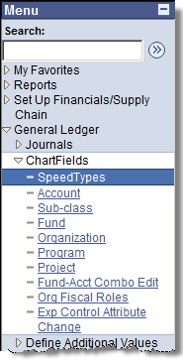

When the SpeedType Search Page opens, enter the SpeedType number.

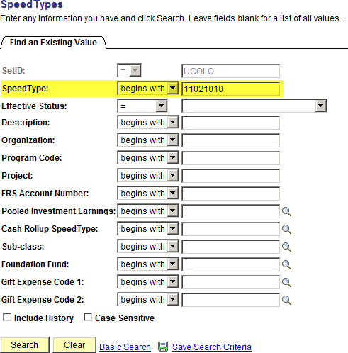

Click on the key.
The SpeedType component opens, and you can select tab that contains the information you are looking for:
- SpeedTypes
- Additional SpeedType Attributes
- Org/Program/Project Attributes
- Fiscal Staff

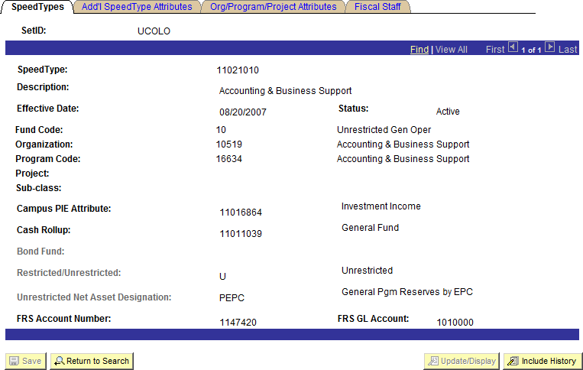

You can also look up SpeedType information in the Cognos Reporting System using the Look Ups folder.

